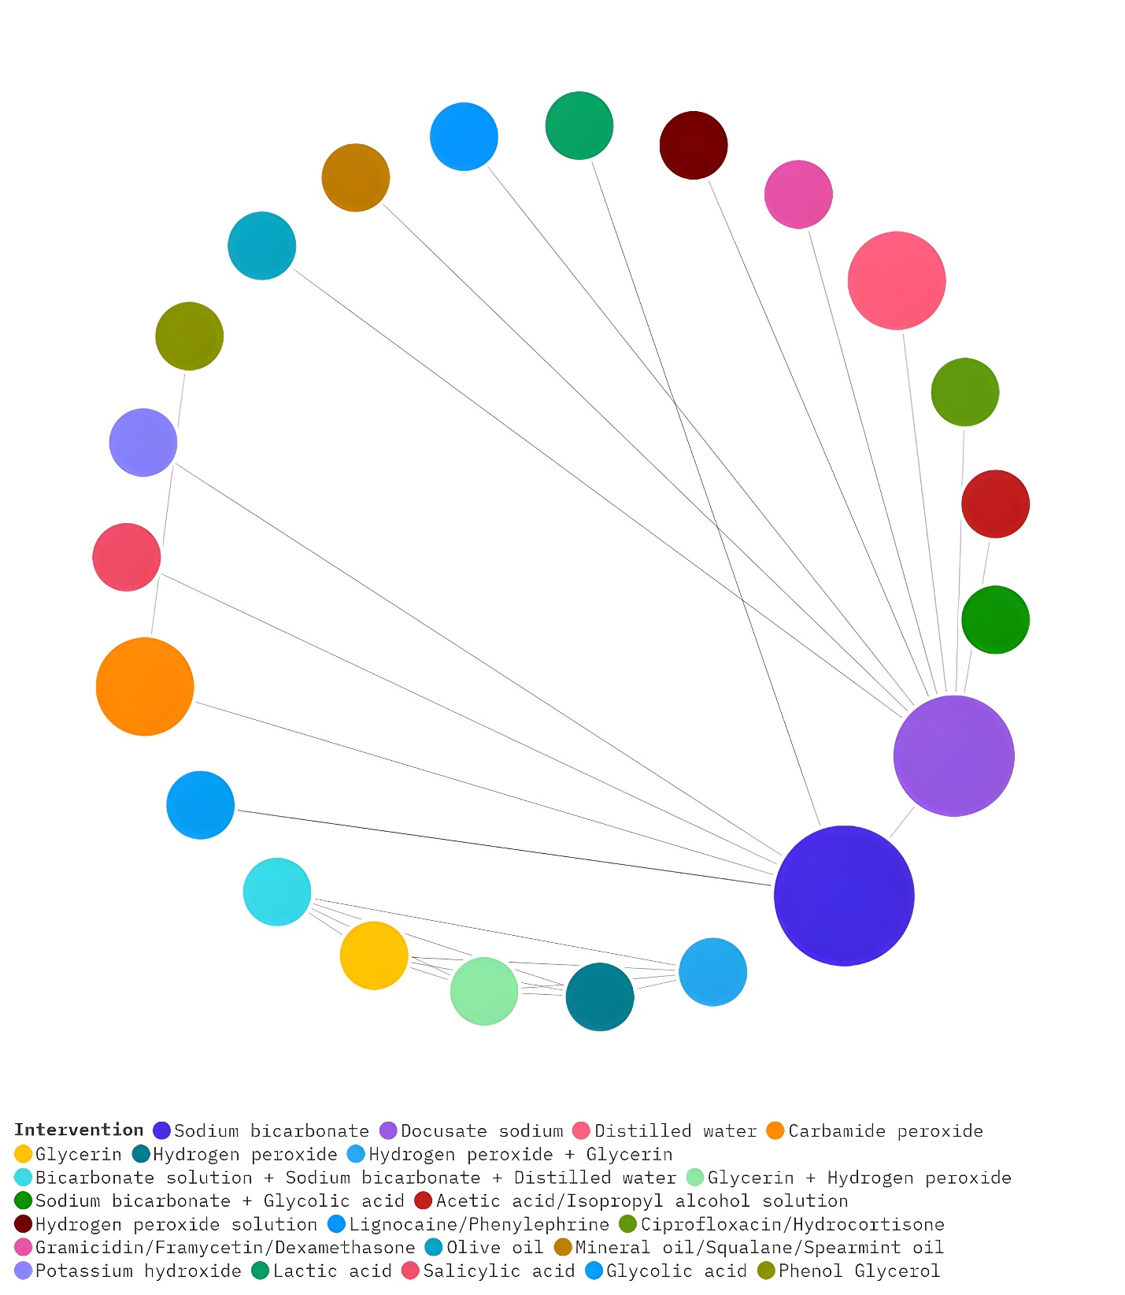

Fig 2. Network graph for the primary outcome: Circles represent each of the cerumenolytics, and the sizes of circles indicate the total numbers of included studies evaluating the respective cerumenolytic