J

Copyright Transfer Form

The authors hereby transfer all copyrights in and to the manuscript titled
“Clinical Profile of Pediatric Patients with Steroid-resistant Nephrotic Syndrome Treated by Cyclophosphamide, Cyclosporin A, Mycophenolate Mofetile and Tacrolimus in Hasan Sadikin General Hospital”

in all forms and media, now or hereafter known, to Jurnal Kedokteran Diponegoro, effective if and when the paper is accepted for publication in the journal. The authors reserve all proprietary right other than copyright, such as patent rights.

Everyone who is listed as an author in this article should have made a substantial, direct, intellectual contribution to the work and should take public responsibility for it.

This paper contains works that have not previously published or not under consideration for publication in other journals.

Corresponding author | Ahmedz Widiasta |  | 11 November 2023
Author 1
Author 2 | Muhammad Khalid Jambak | 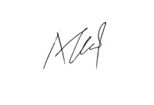 | 12 November 2023

