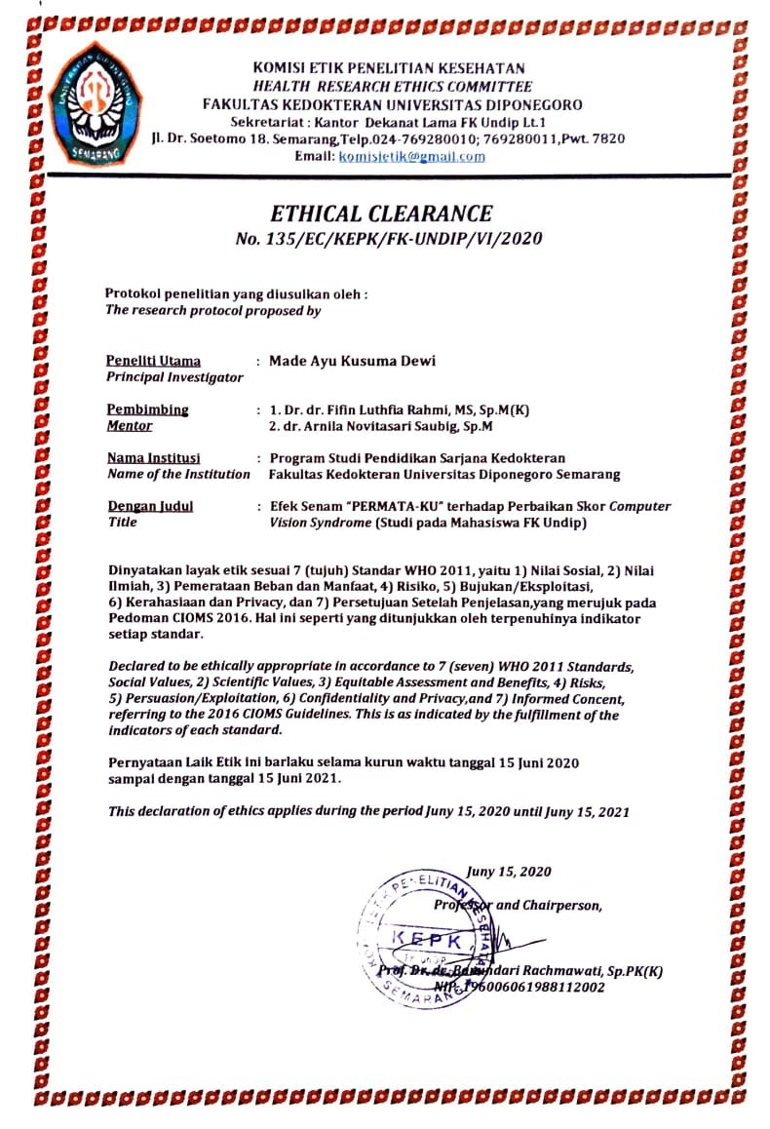
No | Nama | Umur | Angkatan | Jenis Kelamin | SKOR PRE-TEST | SKOR POST-TEST | DELTA | Besar nyeri leher (PRE-TEST) | Besar nyeri bahu (PRE-TEST) | Besar nyeri punggung (PRE-TEST) | Besar nyeri leher (POST-TEST) | Besar nyeri bahu (POST-TEST) | Besar nyeri punggung (POST-TEST) | Kelompok
1 | Aufa | 20 | 17 | L | 8 | 4 | 4 | 9 | 9 | 9 | 2 | 0 | 0 | SENAM
2 | Vynda Ulvyana | 19 | 17 | P | 9 | 5 | 4 | 4 | 2 | 2 | 3 | 2 | 1 | SENAM
3 | Almayang Diaz | 20 | 17 | P | 7 | 4 | 3 | 2 | 0 | 0 | 0 | 0 | 0 | SENAM
4 | Aulia Arinindya Sabila | 21 | 17 | P | 9 | 4 | 5 | 4 | 4 | 4 | 2 | 1 | 1 | SENAM
5 | Hayyu | 20 | 18 | P | 8 | 2 | 6 | 0 | 0 | 2 | 0 | 0 | 0 | SENAM
6 | Nuke Rizqi Rahmawati | 20 | 18 | P | 6 | 3 | 3 | 4 | 0 | 0 | 0 | 0 | 1 | SENAM
7 | Ziki | 20 | 18 | L | 14 | 2 | 12 | 5 | 5 | 5 | 0 | 0 | 0 | SENAM
8 | Margareta | 20 | 18 | P | 8 | 1 | 7 | 3 | 3 | 6 | 0 | 0 | 1 | SENAM
9 | Tsamara Nurwina Nugroho | 19 | 18 | P | 8 | 5 | 3 | 1 | 3 | 6 | 0 | 1 | 1 | SENAM
10 | M Rafly | 19 | 18 | L | 14 | 4 | 10 | 3 | 3 | 3 | 0 | 0 | 0 | SENAM
11 | Arminta Adlina S | 19 | 18 | P | 8 | 5 | 3 | 3 | 6 | 5 | 0 | 5 | 3 | SENAM
12 | Ifan Nugroho | 19 | 19 | L | 13 | 3 | 10 | 6 | 6 | 6 | 1 | 1 | 1 | SENAM
13 | Nurul Puspitasari | 17 | 19 | P | 8 | 3 | 5 | 6 | 6 | 7 | 1 | 1 | 1 | SENAM
14 | Jodie S | 19 | 19 | L | 9 | 6 | 3 | 4 | 0 | 3 | 2 | 0 | 3 | SENAM
15 | Raihan Dhia | 18 | 19 | L | 8 | 0 | 8 | 5 | 1 | 0 | 0 | 5 | 2 | SENAM
16 | Rahma Khusnul Khotimah | 21 | 17 | P | 7 | 8 | -1 | 8 | 6 | 10 | 9 | 1 | 1 | KONTROL
17 | Arfianty NA | 21 | 17 | P | 6 | 10 | -4 | 5 | 0 | 8 | 7 | 1 | 9 | KONTROL
18 | Aulia Salwa Alfaina | 20 | 17 | P | 6 | 1 | 5 | 4 | 2 | 3 | 3 | 0 | 0 | KONTROL
19 | Airiza Fatma Yossineura | 21 | 17 | P | 9 | 7 | 2 | 3 | 4 | 0 | 0 | 0 | 0 | KONTROL
20 | Aulika Alya Paramesti | 20 | 17 | P | 8 | 2 | 6 | 0 | 0 | 0 | 0 | 0 | 0 | KONTROL
21 | Timothy Jordan | 20 | 17 | L | 6 | 3 | 3 | 0 | 0 | 0 | 0 | 0 | 0 | KONTROL
22 | Putri Lenggo Geany | 20 | 17 | P | 8 | 7 | 1 | 1 | 4 | 0 | 5 | 7 | 6 | KONTROL
23 | Daffa Naufal Baihaqi | 20 | 18 | L | 10 | 5 | 5 | 4 | 4 | 6 | 4 | 3 | 4 | KONTROL
24 | Dinda Anita Septiana | 20 | 18 | P | 9 | 5 | 4 | 7 | 7 | 7 | 6 | 6 | 7 | KONTROL
25 | Vinka Dwi Anggita | 20 | 18 | P | 6 | 3 | 3 | 0 | 0 | 0 | 0 | 0 | 0 | KONTROL
26 | Husain Junaedi | 20 | 18 | L | 12 | 9 | 3 | 9 | 3 | 0 | 2 | 2 | 2 | KONTROL
27 | Likha Malikhatul Khusna | 19 | 19 | P | 9 | 2 | 7 | 3 | 1 | 5 | 1 | 4 | 2 | KONTROL
28 | Alya Azkaa Adawya | 18 | 19 | P | 7 | 6 | 1 | 5 | 6 | 6 | 5 | 6 | 2 | KONTROL
29 | George | 19 | 19 | L | 7 | 7 | 0 | 4 | 4 | 7 | 6 | 5 | 5 | KONTROL
30 | Dzaky Edo Bahauddin | 18 | 19 | L | 9 | 8 | 1 | 7 | 2 | 7 | 8 | 5 | 3 | KONTROL

