PREOPERATIVE CARDIAC REHABILITATION IN A 28 YEARS-OLD WOMAN WITH VALVULAR HEART DISEASE

Sri Hastuti Barata^{1*}, Endang Ambarwati², Erna Setiawati³
^{1,2,3}Department of Physical Medicine and Rehabilitation, Faculty of Medicine, Diponegoro University. Dr. Kariadi General Hospital, Semarang, Central Java, Indonesia, 50244.
^{*)} Corresponding author: Email: hastuti.barata@gmail.com

ABSTRACT
Background: Valvular heart disease (VHD) is one third of all heart disease. In industrialized countries, the prevalence is estimated at 2,5% and in developing countries is between twenty to thirty cases per-1000 people. VHD presents a huge health burden worldwide. If heart failure has occured, surgery is the treatment of choice. Cardiorespiratory fitness declined in post-surgical patients. Preoperative cardiac rehabilitation is considered to be able to increase the cardiorespiratory fitness baseline so that postoperative outcomes are better.
Case Presentation: We reported 28 years-old female with severe MS and MR as well as mild TR with symptoms dyspnea on effort which improves with rest. She was the candidate for mitral valve replacement. She was given a 14-days preoperative cardiac rehabilitation program including breathing exercise by pursed lips breathing, effective cough exercise, range of motion exercise, ankle pumping exercise, endurance exercise based on the result of the 6 minutes walking test (6MWT) and inspiratory muscle training (IMT) using threshold IMT.
Conclusion: Preoperative cardiac rehabilitation program improved pulmonary functional capacity, cardiorespiratory fitness and functional activity.
Keyword: valvular heart disease, cardiac rehabilitation, pulmonary functional capacity, cardiorespiratory fitness.

INTRODUCTION
Valvular heart disease is slowly progressive so the patient is not aware until the condition gets worse. If there is heart failure that interferes with activities and treathens patient’s life, the treatment option is valve repair or valve replacement surgery.^{1,2}
Medical rehabilitation of patients with valvular heart disease according to the guideline from the American Association for Cardiac Rehabilitation and Pulmonary Rehabilitation (AACVPR) begins in the preoperative phase, generally two weeks before surgery. Cardiac rehabilitation programs can improve cardiorespiratory fitness, increase clinical outcomes (eg. reduce dyspnea) and the patient's ability to perform activities of daily life. In addition, with preoperative rehabilitation, the postoperative condition are better, the risks and complications of surgery are reduced, the recovery time and duration of treatment are shorter.³⁻⁶
This case report aims to describe the role of preoperative cardiac rehabilitation in patients with valvular heart disease in improving pulmonary functional capacity, cardiorespiratory fitness and daily functional activities.

CASE PRESENTATION
A 28-year-old woman with severe mitral stenosis and regurgitation as well as mild tricuspid regurgitation was referred from the Cardiology Department to the Murai Installation of the Medical Rehabilitation Department, Dr. Kariadi with complaints of shortness of breath when doing activities that are more strenuous than daily activities. Shortness of breath subsides with rest. Shortness of breath got worse in the last 2 weeks accompanied by palpitation, but no chest pain, no orthopnea or paroxysmal nocturnal dyspnea, there was a history of swelling in both legs. The patient was scheduled to have mitral valve replacement surgery.
On physical examination, blood pressure and respiration rate were normal, oxygen saturation was 98%, and jugular venous pressure was normal. There was irregular heart sound 1 and 2, pansystolic murmur 3/6 at the apex, middiastolic murmur 2/4 at the apex. Lung and abdominal examination normal, no edema in extremities. Hematology examinations was normal. Chest radiological examination revealed left atrium (LA) enlargement (figure 1A and 1B). Electrocardiography examination showed normoventricular atrial fibrillation (AF) response, 80 times per minute, normoaxis (figure 2). Echocardiography shows dilated left atrium (LA), left ventricle (LV) and main pulmonary artery (MPA), concentric remodeling LV, normal LV systolic function with 63% LVEF (teichz), decreased right ventricular (RV) systolic function, severe mitral stenosis (MS), severe mitral regurgitation (MR), mild ticuspid regurgitation (TR), and high probability for pulmonary hypertension (figure 3).

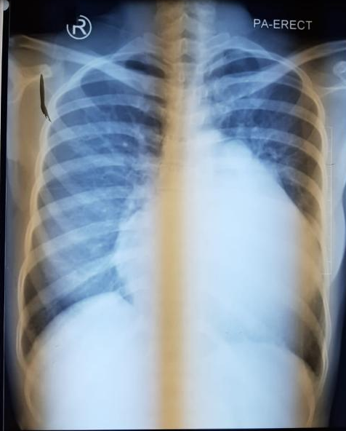 | 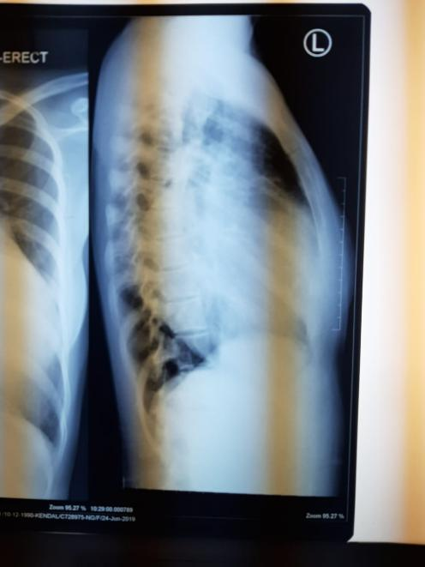
Figure 1. (A) X-ray thorax PA-erect shows LA enlargement | Figure 1. (B) X-ray thorax lateral shows LA enlargement

Figure 2. Electrocardiography shows normoventricular AF response

Figure 3. Echocardiography shows normal LV systolic function with 63% LVEF (teichz)

Patients received medication spironolactone 25 mg/24 hours, furosemide 40 mg/24 hours, digoxin 0.25 mg/24 hours, and Simarc 2 mg/24 hours. The patient was given a preoperative cardiac rehabilitation program for 14 days. The rehabilitation program includes pursed lips breathing exercises, effective cough exercises, ankle pumping exercises, endurance exercises base on the 6MWT results and inspiratory muscle training using the threshold IMT.

DISCUSSION
Cardiovascular changes can occur in all conditions of valvular heart disease. There is myocardial damage with massive myocyte loss and fibrotic repair. As myocardial contractility decreases, the stroke volume decreases, the end-diastolic volume and pressure increase. Ventricular remodeling in response to myocardial loss/overload, causing hypertrophy and dilation to maintain cardiac output. Ventricular load increases both pressure/volume, causing ventricular dysfunction. As a result of these changes, the symptoms of heart failure begin to appear, marked by decreased tolerance to exercise, pulmonary and systemic congestion, edema, especially when the ejection fraction is <30%. Ventricular dysfunction may occur in the left ventricle, right ventricle or both and it is increased by overload due to valve insufficiency and systolic overload (pulmonary/arterial hypertension).⁷⁻⁹
In patients with heart failure, many functional disorders occur, such as decreased muscle strength. There are many factors that are thought to be the cause of this. The first is due to inadequate blood flow resulting in hypoperfusion and prolonged deconditioning. Research by Kasahara et al. demonstrated that blood flow to the muscles in heart failure patients at the time of activity was reduced to two-thirds compared to healthy subjects.¹¹ The second cause is poor nutritional status as the main determinant of respiratory muscle mass which determines the strength or weakness of the respiratory muscles. These nutritional deficiencies can also be caused by changes in metabolic efficiency in patients with heart failure.^{10,12}
Weakness of the skeletal muscles is also thought to occur due to reduced contractility function in patients with heart failure, which is caused by disruption of the function of myofilament proteins. Research by Skinner et al. showed that in patients with heart failure there was a decrease in myosin heavy protein in the muscles. Myosin is the most abundant myofilament protein in muscle and the primary determinant of the mechanics of muscle fiber contraction. In heart failure, the diaphragm abnormality occurs earlier and wider than the limb muscles. In this situation there is an increase in sphingomyelinase (SMase) and ceramide activity. SMases and ceramides result in dysfunction of diaphragm contraction through reactive oxygen species (ROS) from mitochondria and nicotinamide adenine dinucleotide phosphate/NAD (P) H oxidase 2 (NOx2). The pathophysiology can be seen in Figure 4.¹²

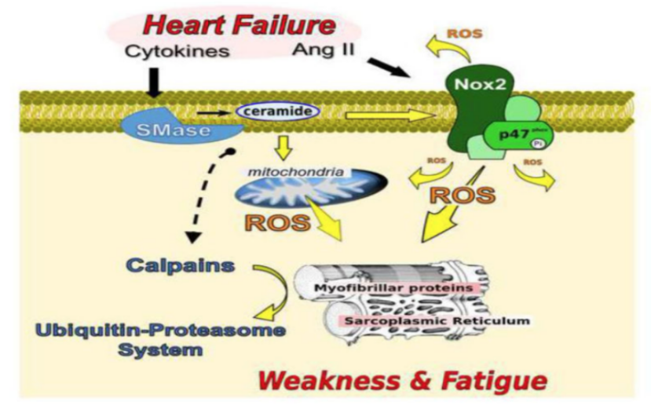
Figure 4. Pathophysiology of muscle weakness in heart failure.
The decreased strength and function of the respiratory muscles will cause compensation in the form of changes in breathing patterns where there is an increase in the breathing ratio so that the breath becomes short and fast, and a decrease of tidal volume. Short and fast breaths lead to an increase in the dead space/tidal volume ratio that compromises alveolar ventilation and oxygen exchange. The existence of impaired function of the inspiratory muscles in this condition will worsen oxygen exchange and oxygen flow to the tissues.^{12,13}
A chronic heart failure causes patients inactivity, because they become tired more easily, resulting in reduced exercise tolerance and limited daily life activities. Therefore, one of the main goals of cardiac rehabilitation is to improve exercise tolerance and cardiorespiratory fitness in patients with heart failure. With cardiac rehabilitation, it is hoped that the symptoms of shortness of breath can be reduced during exercise and activities of daily life.^{14,15}
Cardiac rehabilitation improves cardiorespiratory fitness by integrating cardiovascular, respiratory, and musculoskeletal functions. Breathing exercises can improve breathing patterns to be more efficient, reduce shortness of breath by reducing work of breathing (WOB) and improve alveolar ventilation. In this patient, pursed lips breathing with a frequency of 30 breaths was given three times a day. The exercise is done by inhaling through the nose for a few seconds with the mouth closed, then exhaling slowly through the constricted mouth (like blowing out a candle). This breathing exercise can increase gas exchange by increasing arterial oxygenation and saturation (SaO2) and decreasing carbon dioxide levels, especially with slow and deep breathing patterns.^{10,16}
Taking a deep breath while on a pursed lips breathing can increase the movement of the ribs effectively, allowing a better flow of air into and out of the lungs. During deep breathing exercises, the diaphragm and intercostal muscles contracts, lowering the pressure in the chest cavity. This allows air to enter the lungs and fill the lung capacity to its fullest. With deep breathing exercises, there is an increased demand for oxygen to the respiratory muscles. It stimulates a chemosensitive area that is located bilaterally in the medulla oblongata, thereby stimulating the dorsal group of the nucleus tractus solitarius to send signals to the inspiratory muscle group which causes adequate respiration. It is through this mechanism that causes an increase in lung functional capacity.¹⁷
In addition to breathing exercises, aerobic exercise is also given based on the 6MWT results. Walking exercise is done every day, 2 times a day for 10 minutes with an intensity of 40%. Aerobic exercise has an influence on the physiological adaptation of the respiratory system in the form of increasing the ability to expand the lungs, increasing the endurance of the respiratory muscles and pulmonary capillaries so that oxygen uptake is greater, and increasing the surface area of the alveoli, allowing increased gas exchange. Range of motion exercises and ankle pumping exercises can also result in higher ventilation during exercise.^{18,19}
Strengthening exercises for inspiratory muscles with a threshold IMT were performed at a frequency of 2 times a day every 8 hours, with an intensity of 5x10 maximum repetitions (RM), for 10 minutes. Before doing the exercise, measuring 10 times RM was taken to determine the initial load. Re-measurement was carried out on day 8 to determine the next training load. Strengthening exercises will elicit a physiological response in which there is an increase in muscle performance and circulation. Initially, there may be an increase in the number of motor units recruited, speed, and synchronized muscle excitability. Continued exercise will be able to increase fiber size and muscle strength and induce an increase in the size and number of mitochondria in cells. Stronger and more endurance of inspiratory muscles will help the cardiorespiratory system to increase oxygen uptake and distribution thereby increasing VO₂max. Improvement of inspiratory muscles endurance also prevents activation of the metaboreflex, a reflex that blocks the delivery of oxygen to the skeletal muscles and causes fatigue.^{10,20}
The presence of stronger inspiratory muscles increases tidal volume and maintains ventilation, thereby increasing oxygen saturation and resulting in better cardiorespiratory fitness. Cahalin et al. stated that the threshold IMT can prevent the accumulation of metabolites of the inspiratory muscles due to a lack of oxygen distribution which stimulates vasoconstriction due to sympathetic nerve activation and decreased peripheral nerve flow. With better oxygen delivery, the peripheral vasoconstriction caused by sympathetic nerve activation will be reduced so that there is an increase in peripheral blood flow which can make the patient become fit and have good endurance in carrying out a cardiorespiratory fitness test assessed by 6MWT.²¹
After 14 days of undergoing the cardiac rehabilitation program, the patient’s lung functional capacity was obtained as measured by the FVC value increase from 2300 ml before exercise to 2660 ml. The cardiorespiratory fitness as measured by VO2max value also increased, from 14.87 ml/kg/minute to 16.22 ml/kg/ minute. The patient feels that breath more relieved, she is able to do slightly heavier activities without shortness of breath, such as arranging the bed and she is able to walk longer distances.

CONCLUSION
Cardiac rehabilitation that starts before surgery aims to improve functional capacity, reduce symptoms, reduce risk factors, increase self-stability and emotional stability so that the quality of life becomes better. The rehabilitation program provided must be comprehensive and requires good collaboration between cardiologists, medical rehabilitation doctors, physiotherapists and of course the patient and his family. There is a need for medical evaluation, prescribing proper exercise, modifying cardiac risk factors, education and counseling in order to increase patient knowledge and awareness of the disease and the importance of an exercise program.

REFERENCES
- Maganti K, Rigolin VH, Sarano ME, Bonow RO. Valvular heart disease: diagnosis and management. Mayo Clin Proc 2010;85(5):483–500.
- Nishimura RA, Otto CM, Bonow RO, Carabello BA, Erwin JP, Guyton RA, et al. 2014 AHA/ACC guideline for the management of patients with valvular heart disease: executive summary: a report of the american college of cardiology/american heart association task force on practice guidelines. J Am Coll Cardiol 2014 Jun 10;63(22):2438–88.
- Rio PP, Ismail MT, Arso IA. rehabilitation program in a patient undergoing mitral and aortic valve replacement surgery. Acta Cardiologia Indonesiana 2017;3(1):57–60.
- Hayta E, Korkmaz Ö. Cardiac rehabilitation increases the reliability of the 6-minute walk test in patients after coronary artery bypass graft surgery. Heart Surg Forum 2017;20(6):247–51.
- Macedo RM De, Faria-neto JR, Costantini CO, Casali D. Phase Ⅰ of cardiac rehabilitation: a new challenge for evidence based physiotherapy. World J Cardiol 2011;3(7):248–55.
- Hulzebos EH, Smit Y, Helders PP, van Meeteren NL. Preoperative physical therapy for elective cardiac surgery patients (review). In: Cochrane library: cochrane database syst rev. London: John Wiley & Sons, Ltd; 2012. p.1–12.
- Lindman BR, Bonow RO, Otto CM. Aortic valve disease. In: Bonow RO, editor. Braunwald’s heart disease: a textbook of cardiovascular medicine. 11th ed. Philadelphia: Saunders Elsevier Inc; 2019. p.1389–402.
- Thomas JD, Bonow RO. Mitral valve disease. In: Bonow RO, editor. Braunwald’s heart disease: a textbook of cardiovascular medicine. 11th ed. Philadelphia: Saunders Elsevier Inc; 2019. p.1415–28.
- Pellikka PA. Tricuspid, pulmonic, and multivalvular disease. In: Bonow RO, editor. Braunwald’s heart disease: a textbook of cardiovascular medicine. 11th ed. Philadelphia: Saunders Elsevier Inc; 2019. p.1455–61.
- De Troyer A, Estenne M, Yernault JC. Disturbance of respiratory muscle function in patients with mitral valve disease. Am J Med 1980;69(6):867–73.
- Kasahara Y, Izawa K, Watanabe S, Osada N, Omiya K. The relation of respiratory muscle strength to disease severity and abnormal ventilation during exercise in chronic heart failure patients. Res Cardiovasc Med 2015;4(4):6.
- Skinner D, Sikkema KJ. Diaphragm abnormalities in heart failure and aging: mechanisms and integration of cardiovascular and respiratory pathophysiology. HHS Public Access 2017;20(1):48–55.
- Edwards AM, Walker RE. Inspiratory muscle training and endurance: a central metabolic control perspective. Int J Sports Physiol Perform 2009;4(1):122–8.
- Hart N, Kearney MT, Pride NB, Green M, Lofaso F, Shah AM, et al. Inspiratory muscle load and capacity in chronic heart failure. Thorax. 2004;59(6):477–82.
- Merwe J Van Der, Casselman F. Mitral valve replacement: current and future perspectives. Open J Cardiovasc Surg 2017;9:1–6.
- El-sobkey SB, Gomaa M. Assessment of pulmonary function tests in cardiac patients. J of the Saudi Heart Assoc 2011;23(2):81–6.
- Gosselink R, Dal Corso S. Respiratory muscle training. In: Frownfelter D, Dean E, editors. Cardiovascular and pulmonary physical therapy: evidence to practice. 5th ed. Vancouver: Elsevier Health Sciences; 2013. p.419-26.
- Murray JA, Mahler DA. Inspiratory muscle training. In: Hodgkin JE, Celli BR, Connors GL, editors. Pulmonary rehabilitation: guidelines to success. 4th ed. St. Louis: Mosby Elsevier; 2009. p.143-51.
- Shakuri SK, Salekzamani Y, Taghizadieh A, Sabbagh-Jadid H, Soleymani J, Sahebi L, et al. Effect of respiratory rehabilitation before open cardiac surgery on respiratory function: a randomized clinical trial. J Cardiovasc Thorac Res 2015;7(1):13–7.
- McConnell A. Respiratory muscle training: theory and practice. London: Churchill Livingstone Elsevier; 2013. p.926.
- Cahalin LP, Arena R, Guazzi M, Myers J, Cipriano G, Chiappa G, et al. Inspiratory muscle training in heart disease and heart failure: a review of the literature with a focus on method of training and outcomes. Expert Rev Cardiovasc Ther 2013;11(2):161–7.

