Lampiran 1. Ethical Clearance
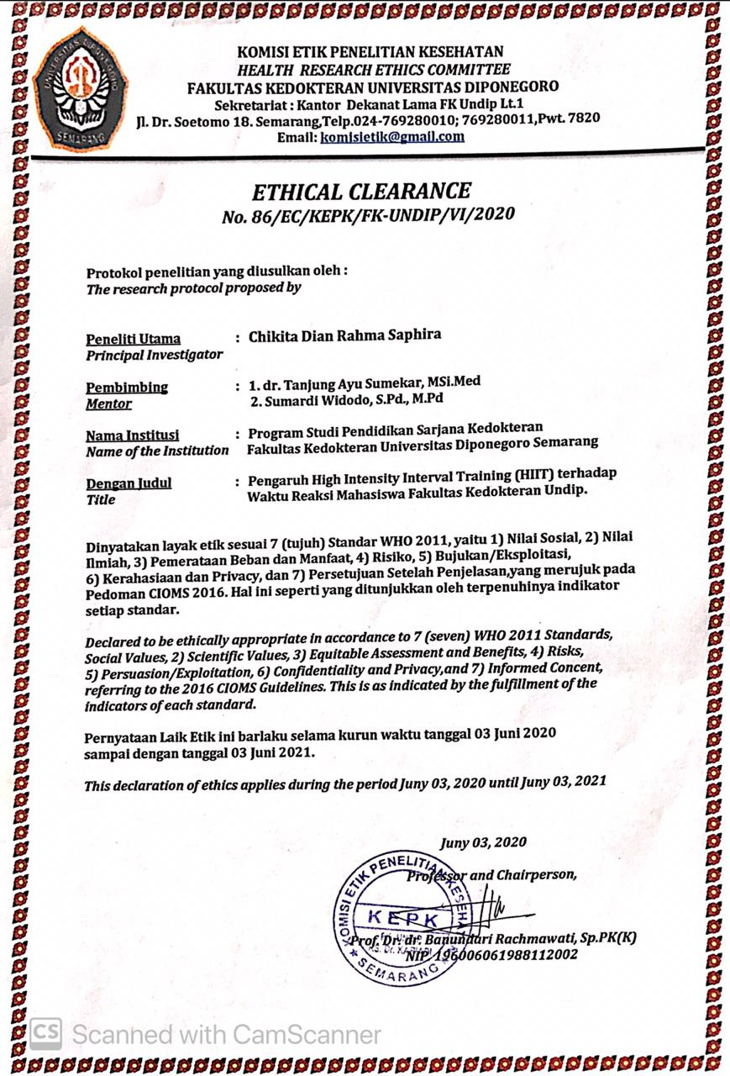

Lampiran 2. Surat persetujuan setelah penjelasan
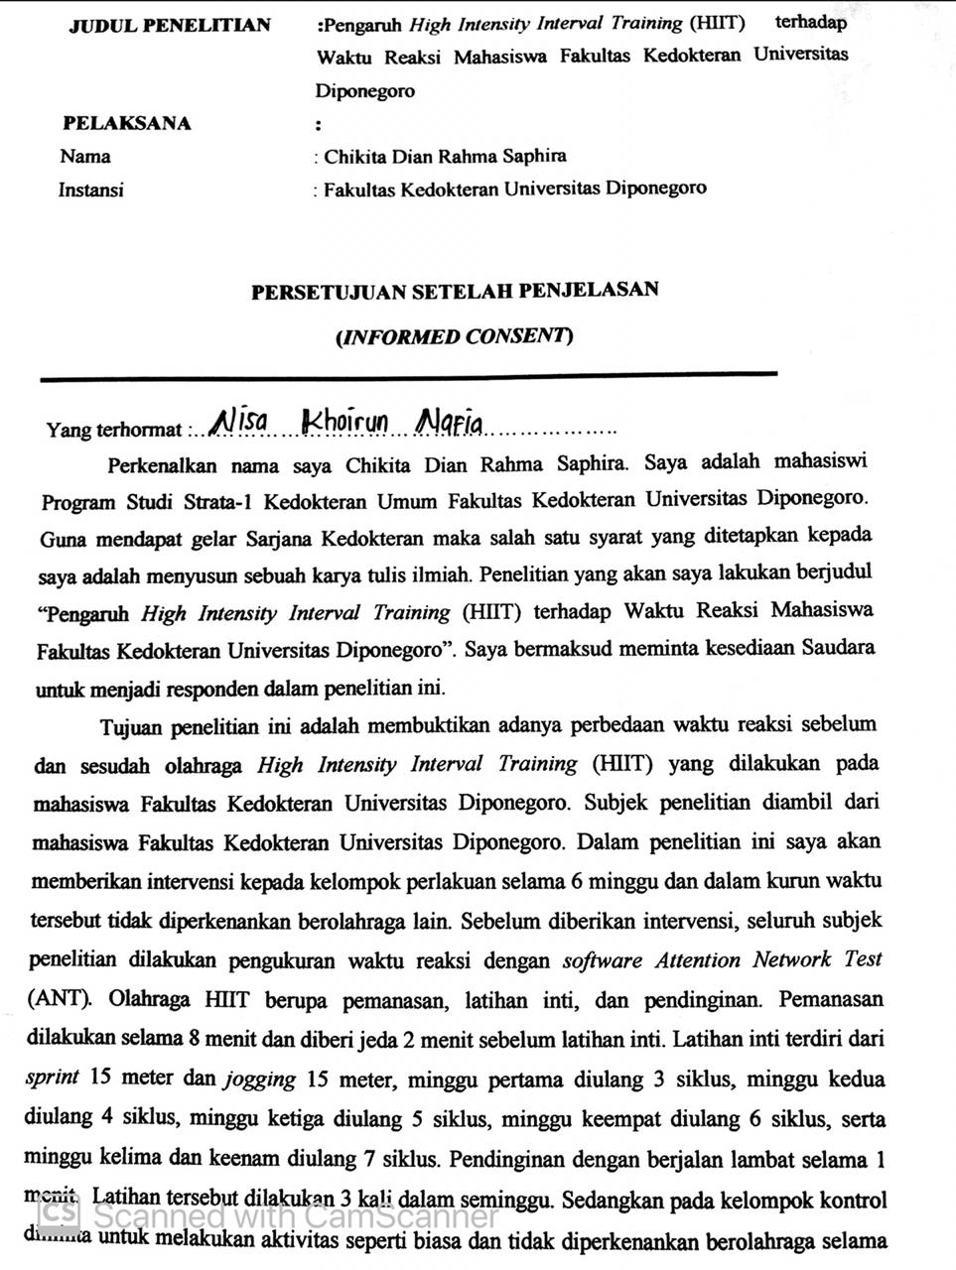

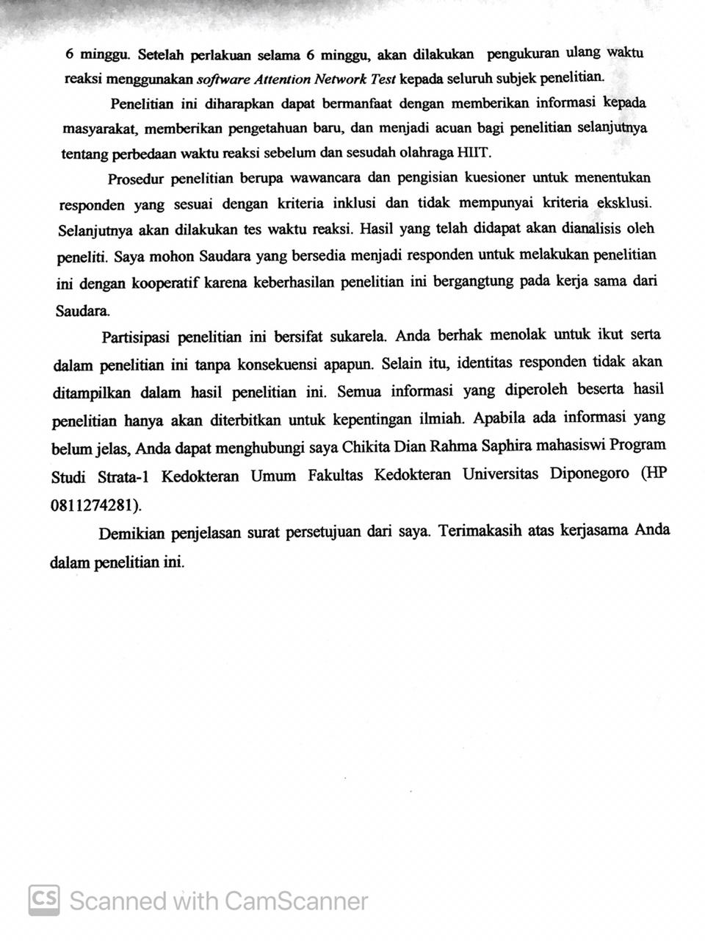

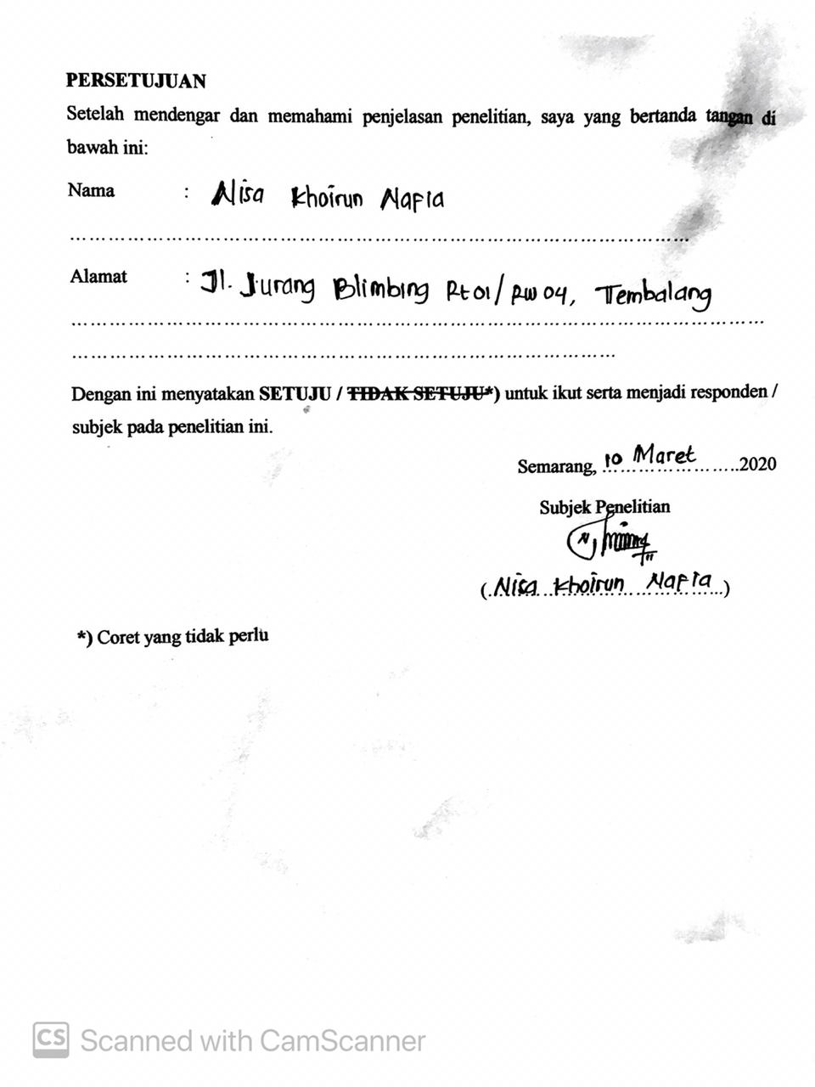

Lampiran 3. Kuesioner sampel penelitian KTI
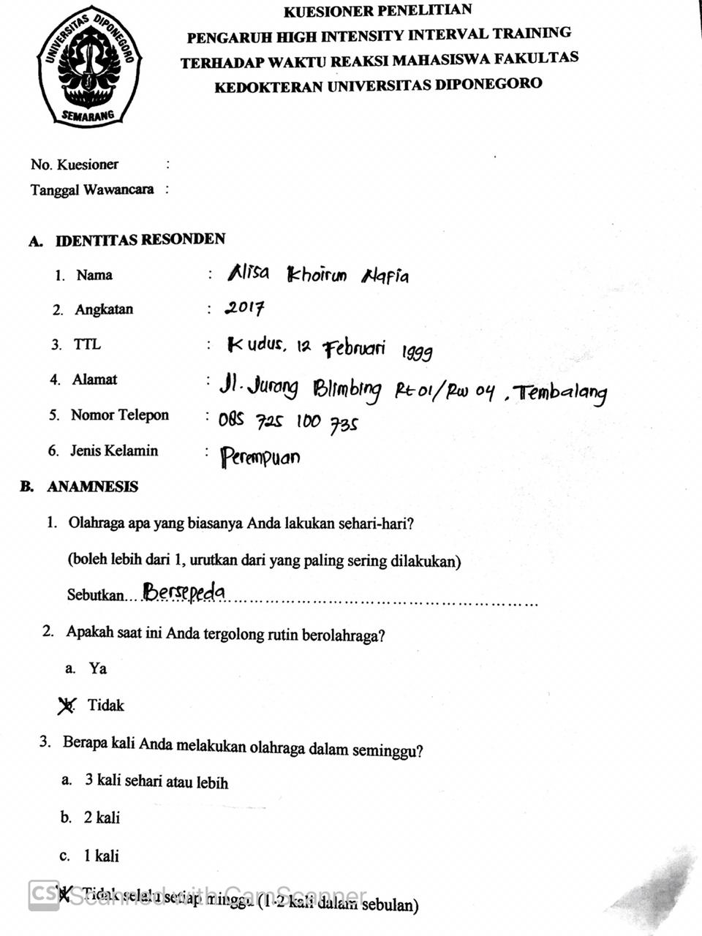

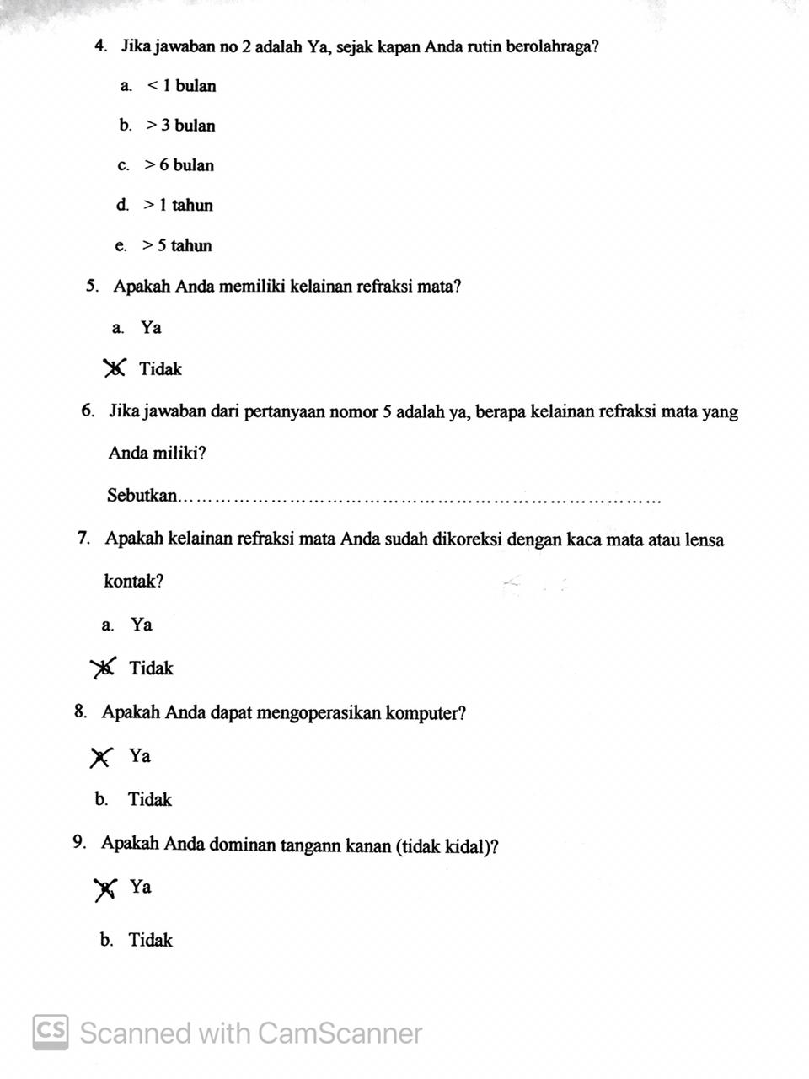

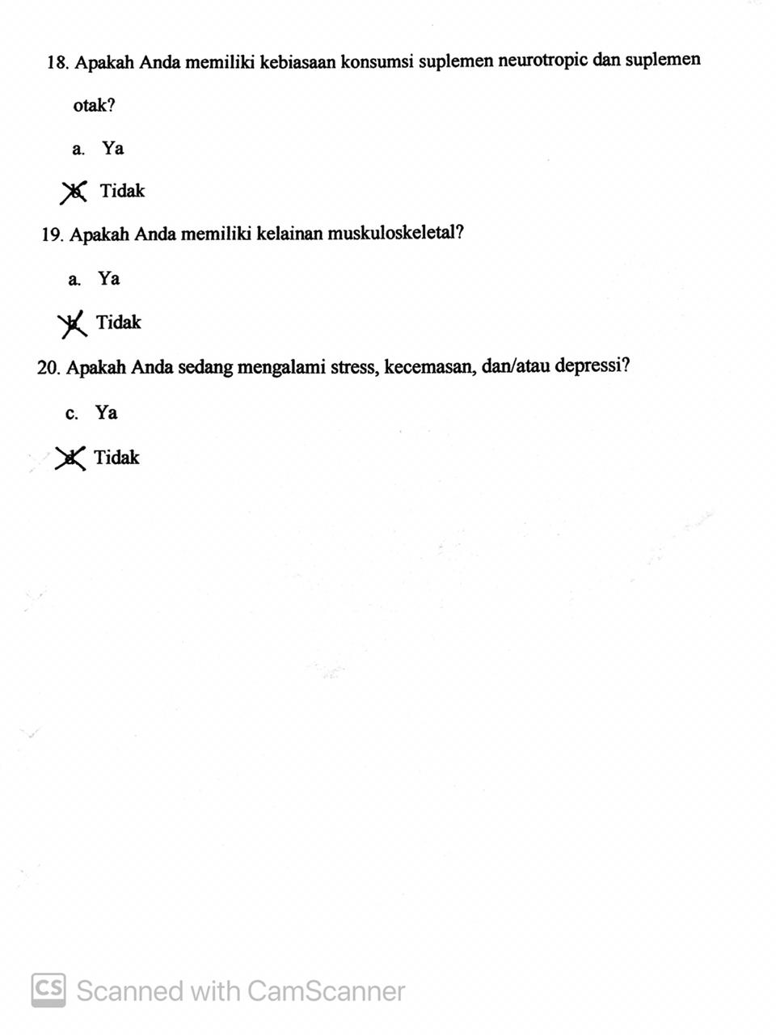

Lampiran 4. Kuesioner gangguan tidur The Pittsburgh Sleep Quality Index (PSQI)
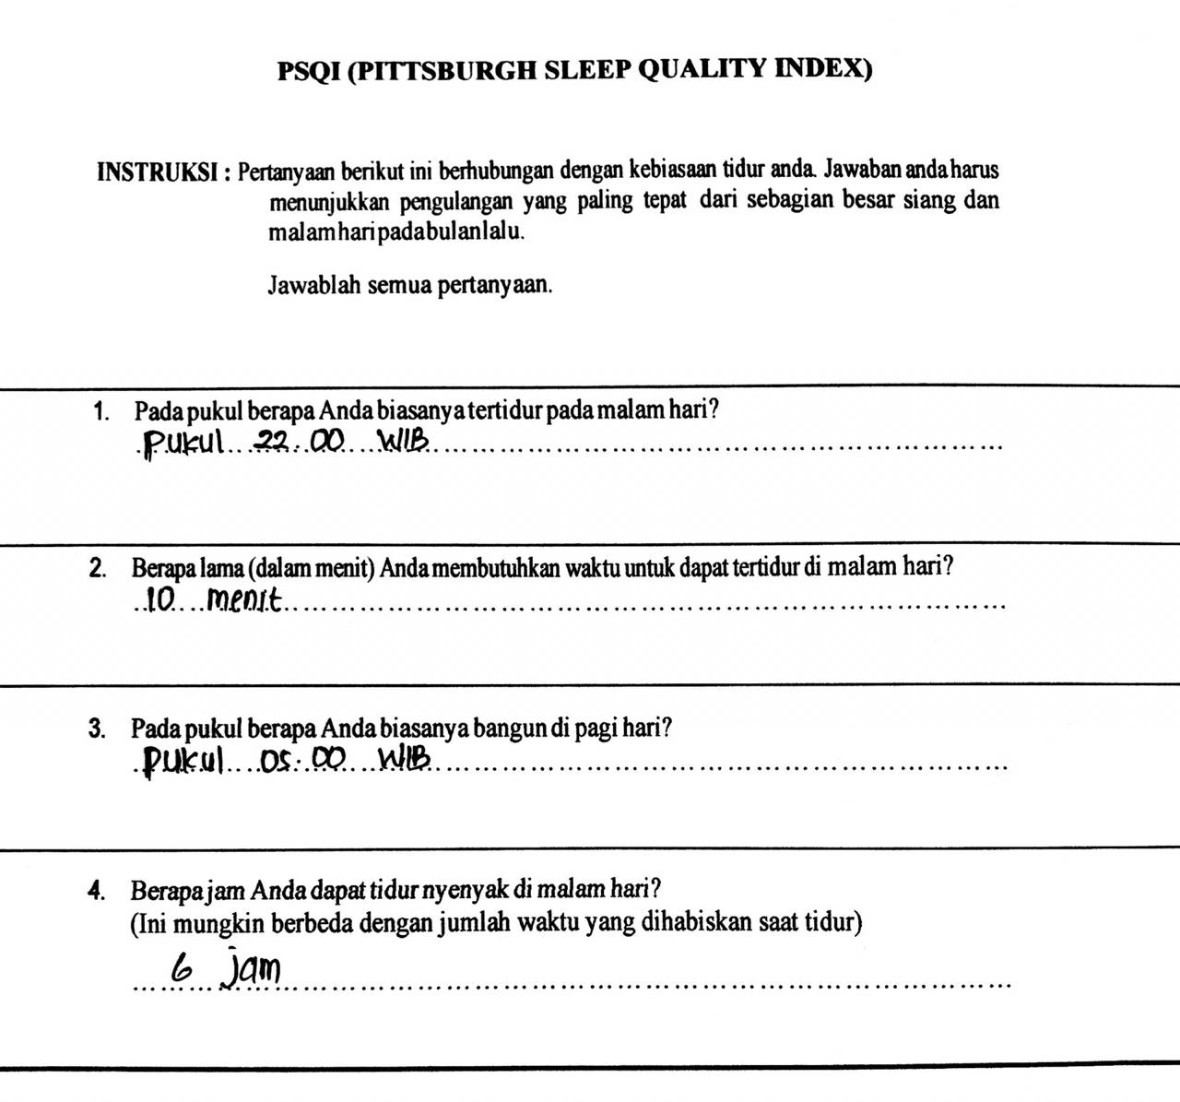

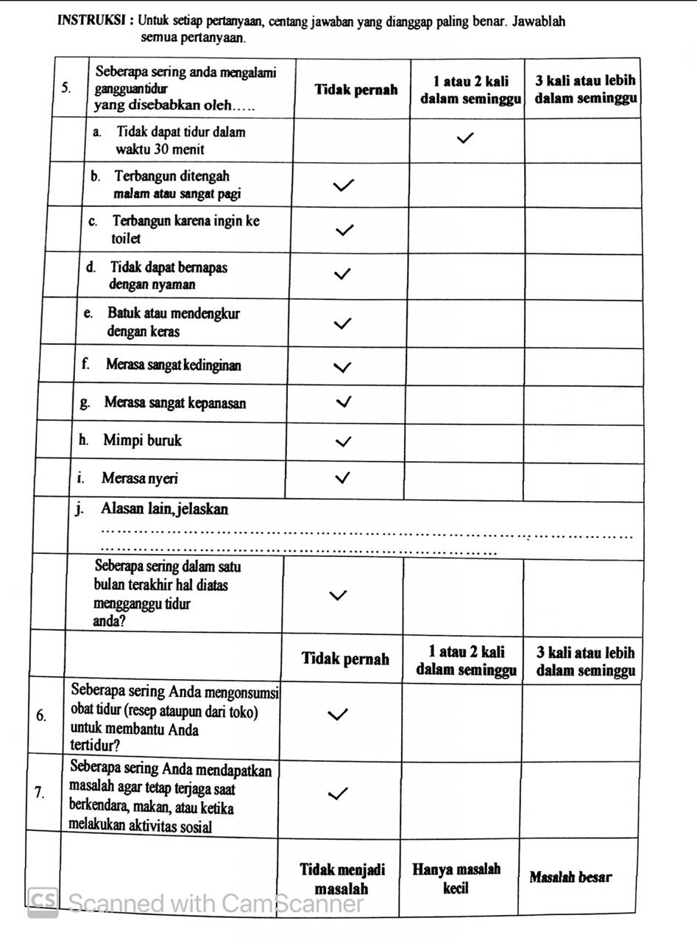

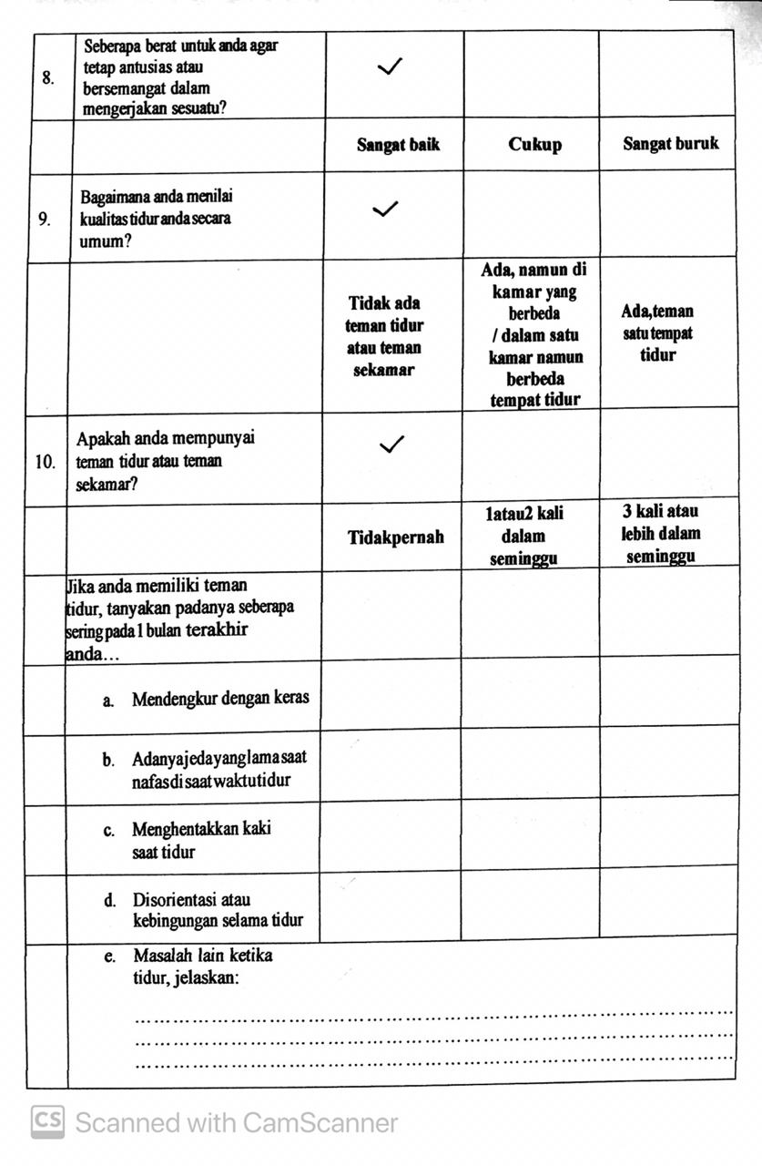

Lampiran 5. Data subjek penelitian
Kode | Angkatan | IMT | Usia | Pre-test | Post-test | Selisih
K1 | 2017 | 21,06 | 21 | 583 | 623 | 40
K2 | 2017 | 21,89 | 19 | 669 | 568 | -101
K3 | 2017 | 24,65 | 21 | 700 | 637 | -63
K4 | 2017 | 22,13 | 20 | 532 | 508 | -24
K5 | 2017 | 19,7 | 21 | 622 | 523 | -99
K6 | 2017 | 22,64 | 20 | 518 | 539 | 21
K7 | 2017 | 20,94 | 21 | 512 | 592 | 80
K8 | 2017 | 24,76 | 20 | 727 | 627 | -100
K9 | 2018 | 24,61 | 19 | 662 | 571 | -91
K10 | 2018 | 22,37 | 19 | 652 | 589 | -63
K11 | 2018 | 21,51 | 19 | 651 | 611 | -40
K12 | 2017 | 24,19 | 19 | 480 | 474 | -6
K13 | 2017 | 21,45 | 20 | 590 | 575 | -15
K14 | 2017 | 23,98 | 21 | 716 | 613 | -103
K15 | 2017 | 21,39 | 21 | 562 | 561 | -1
P1 | 2017 | 19,78 | 21 | 600 | 540 | -60
P2 | 2017 | 18,94 | 21 | 570 | 503 | -67
P3 | 2017 | 24,91 | 19 | 765 | 515 | -250
P4 | 2018 | 22,31 | 19 | 483 | 443 | -40
P5 | 2018 | 24,03 | 19 | 542 | 510 | -32
P6 | 2017 | 19,65 | 20 | 567 | 448 | -119
P7 | 2017 | 19,69 | 21 | 644 | 587 | -57
P8 | 2017 | 24,73 | 20 | 625 | 457 | -168
P9 | 2017 | 21,34 | 21 | 650 | 473 | -177
P10 | 2017 | 22,25 | 20 | 486 | 568 | 82
P11 | 2017 | 19,6 | 20 | 639 | 645 | 6
P12 | 2017 | 23,44 | 20 | 579 | 494 | -85
P13 | 2017 | 23 | 20 | 622 | 511 | -111
P14 | 2017 | 21,91 | 19 | 517 | 547 | 30

