Hasil Uji Daya Terima
- Warna
Panelis | P0 (0% : 0%) | P1 (90% : 10%) | P2 (80% : 20%) | P3 (70% : 30%)
1 | 1 | 4 | 4 | 4
2 | 4 | 4 | 4 | 4
3 | 2 | 4 | 3 | 4
4 | 5 | 5 | 5 | 5
5 | 5 | 5 | 5 | 5
6 | 4 | 5 | 4 | 5
7 | 3 | 3 | 3 | 4
8 | 2 | 4 | 4 | 4
9 | 4 | 4 | 4 | 4
10 | 5 | 4 | 4 | 4
11 | 3 | 4 | 4 | 5
12 | 5 | 5 | 5 | 4
13 | 2 | 4 | 3 | 3
14 | 4 | 5 | 5 | 4
15 | 3 | 4 | 5 | 4
16 | 4 | 4 | 4 | 4
17 | 5 | 4 | 4 | 3
18 | 2 | 3 | 4 | 5
19 | 4 | 4 | 2 | 3
20 | 4 | 4 | 4 | 4
21 | 4 | 4 | 4 | 4
22 | 5 | 5 | 5 | 5
23 | 2 | 3 | 4 | 3
24 | 4 | 3 | 4 | 4
25 | 2 | 4 | 3 | 5
26 | 4 | 3 | 3 | 3
27 | 4 | 4 | 4 | 4
28 | 4 | 4 | 4 | 4
29 | 2 | 4 | 4 | 2
30 | 5 | 4 | 3 | 3
Jumlah | 107 | 121 | 118 | 119
Rata-rata | 3,6 | 4,0 | 3,9 | 4,0

- Aroma
Panelis | P0 (0% : 0%) | P1 (90% : 10%) | P2 (80% : 20%) | P3 (70% : 30%)
1 | 4 | 4 | 3 | 2
2 | 5 | 5 | 3 | 4
3 | 4 | 4 | 4 | 4
4 | 4 | 5 | 4 | 4
5 | 1 | 4 | 4 | 2
6 | 4 | 4 | 4 | 5
7 | 5 | 4 | 4 | 4
8 | 1 | 3 | 4 | 3
9 | 4 | 3 | 3 | 4
10 | 5 | 4 | 4 | 5
11 | 3 | 2 | 4 | 5
12 | 5 | 4 | 4 | 4
13 | 2 | 3 | 3 | 3
14 | 4 | 5 | 5 | 4
15 | 3 | 5 | 5 | 5
16 | 4 | 4 | 4 | 5
17 | 5 | 5 | 4 | 3
18 | 4 | 3 | 3 | 5
19 | 4 | 5 | 3 | 4
20 | 2 | 4 | 4 | 4
21 | 4 | 4 | 3 | 3
22 | 4 | 5 | 4 | 4
23 | 4 | 4 | 5 | 4
24 | 4 | 3 | 3 | 3
25 | 4 | 4 | 5 | 2
26 | 2 | 3 | 3 | 4
27 | 4 | 4 | 4 | 3
28 | 4 | 3 | 4 | 3
29 | 4 | 3 | 3 | 3
30 | 4 | 3 | 4 | 3
Jumlah | 111 | 116 | 114 | 111
Rata-rata | 3,7 | 3,9 | 3,8 | 3,7

- Tekstur
Panelis | P0 (0% : 0%) | P1 (90% : 10%) | P2 (80% : 20%) | P3 (70% : 30%)
1 | 3 | 4 | 4 | 2
2 | 3 | 3 | 5 | 5
3 | 3 | 5 | 2 | 4
4 | 2 | 4 | 4 | 4
5 | 3 | 3 | 4 | 2
6 | 4 | 4 | 4 | 4
7 | 3 | 4 | 4 | 4
8 | 2 | 3 | 3 | 2
9 | 3 | 4 | 3 | 3
10 | 2 | 5 | 4 | 3
11 | 3 | 3 | 4 | 5
12 | 5 | 3 | 4 | 3
13 | 2 | 4 | 4 | 3
14 | 4 | 5 | 5 | 4
15 | 3 | 5 | 5 | 4
16 | 5 | 4 | 4 | 5
17 | 3 | 5 | 4 | 4
18 | 3 | 5 | 3 | 4
19 | 3 | 5 | 2 | 3
20 | 3 | 3 | 2 | 1
21 | 3 | 4 | 3 | 2
22 | 3 | 4 | 4 | 4
23 | 2 | 4 | 4 | 4
24 | 4 | 3 | 3 | 3
25 | 3 | 4 | 3 | 2
26 | 3 | 3 | 3 | 3
27 | 3 | 4 | 2 | 4
28 | 4 | 3 | 3 | 4
29 | 3 | 4 | 3 | 2
30 | 4 | 3 | 3 | 4
Jumlah | 94 | 117 | 105 | 101
Rata-rata | 3,1 | 3,9 | 3,5 | 3,4

- Rasa
Panelis | P0 (0% : 0%) | P1 (90% : 10%) | P2 (80% : 20%) | P3 (70% : 30%)
1 | 4 | 5 | 4 | 3
2 | 4 | 4 | 5 | 4
3 | 3 | 5 | 3 | 2
4 | 3 | 5 | 5 | 5
5 | 2 | 4 | 4 | 3
6 | 4 | 5 | 5 | 4
7 | 3 | 4 | 4 | 3
8 | 3 | 5 | 3 | 4
9 | 4 | 3 | 3 | 3
10 | 3 | 3 | 4 | 2
11 | 3 | 3 | 5 | 5
12 | 5 | 3 | 5 | 3
13 | 3 | 4 | 4 | 4
14 | 5 | 5 | 5 | 5
15 | 4 | 5 | 5 | 4
16 | 5 | 4 | 3 | 4
17 | 5 | 4 | 3 | 2
18 | 4 | 5 | 3 | 3
19 | 4 | 5 | 3 | 3
20 | 3 | 4 | 5 | 2
21 | 3 | 3 | 2 | 2
22 | 4 | 5 | 5 | 4
23 | 3 | 4 | 4 | 3
24 | 3 | 4 | 4 | 4
25 | 3 | 5 | 5 | 2
26 | 3 | 2 | 2 | 2
27 | 3 | 3 | 3 | 4
28 | 4 | 3 | 4 | 4
29 | 4 | 4 | 4 | 3
30 | 4 | 4 | 4 | 3
Jumlah | 108 | 122 | 118 | 99
Rata-rata | 3,6 | 4,1 | 3,9 | 3,3

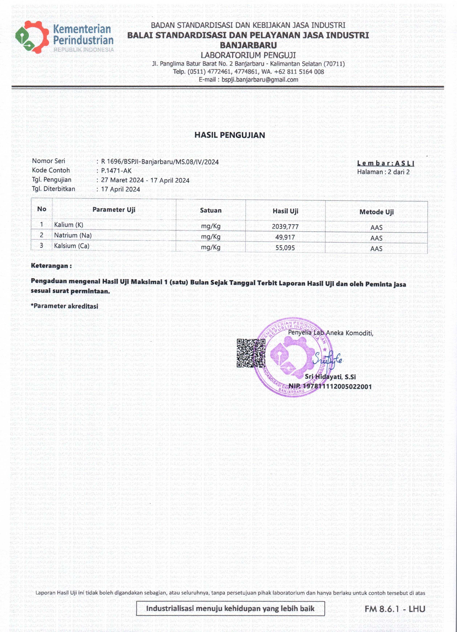
Hasil Uji Mutu Kimia

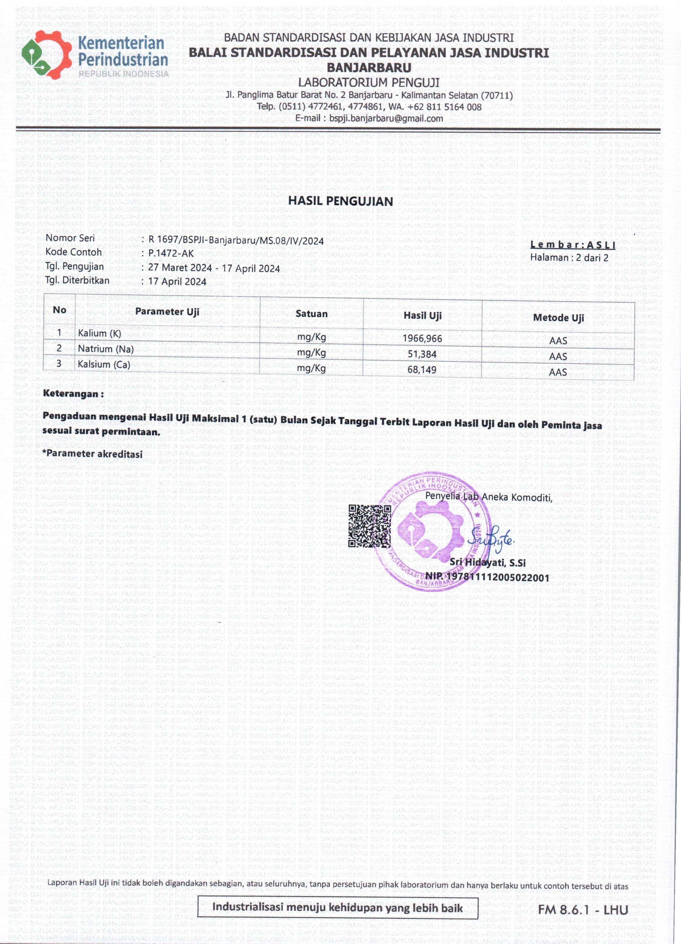

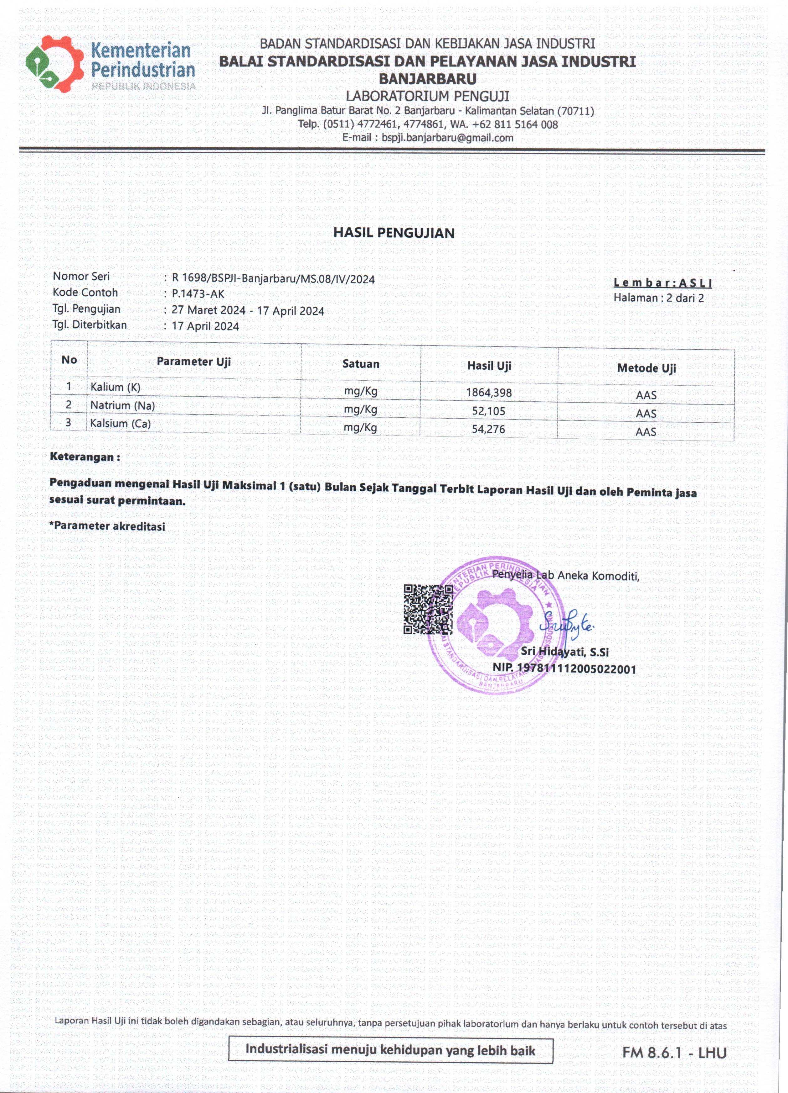

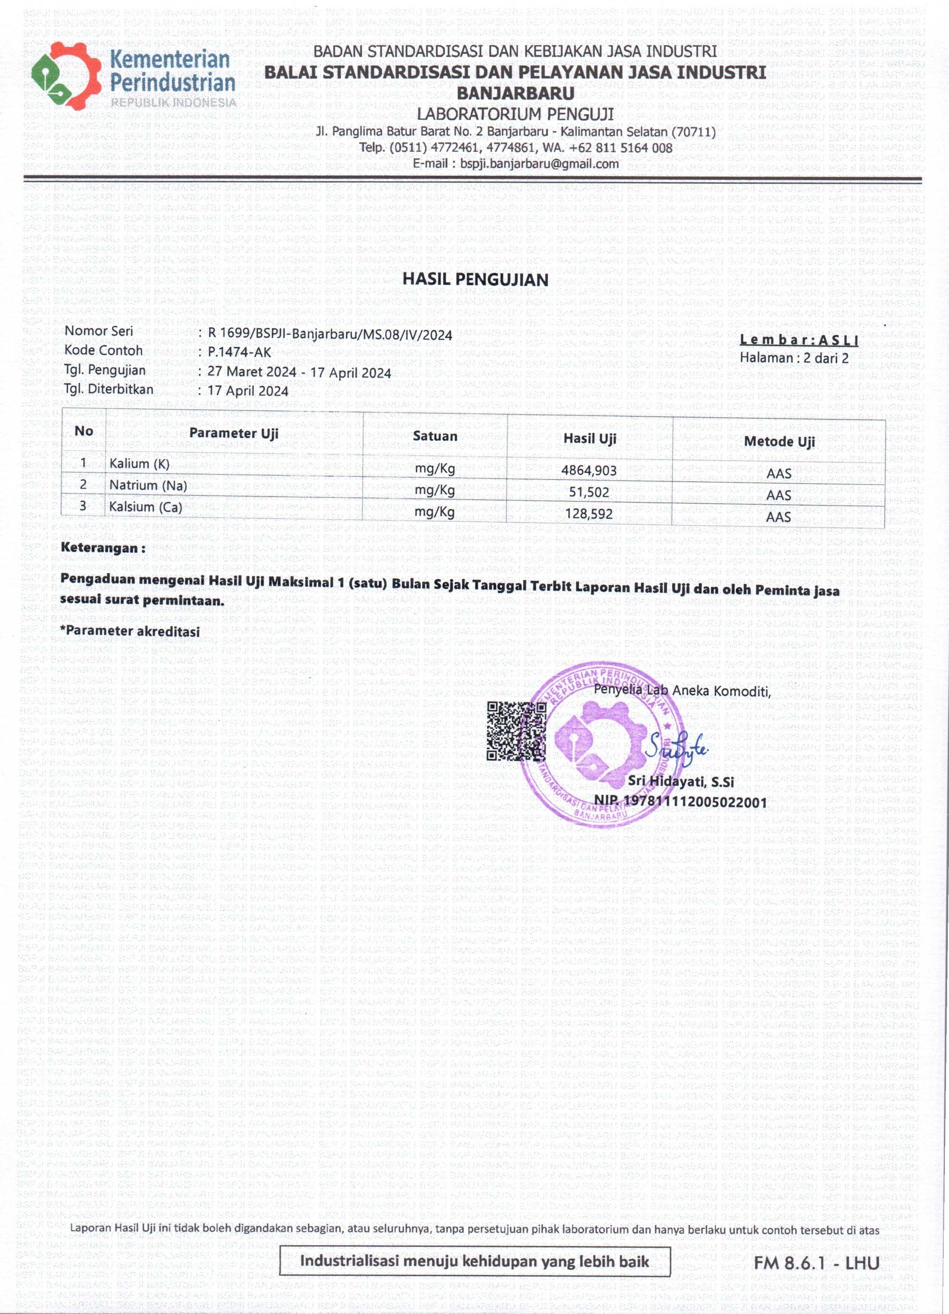

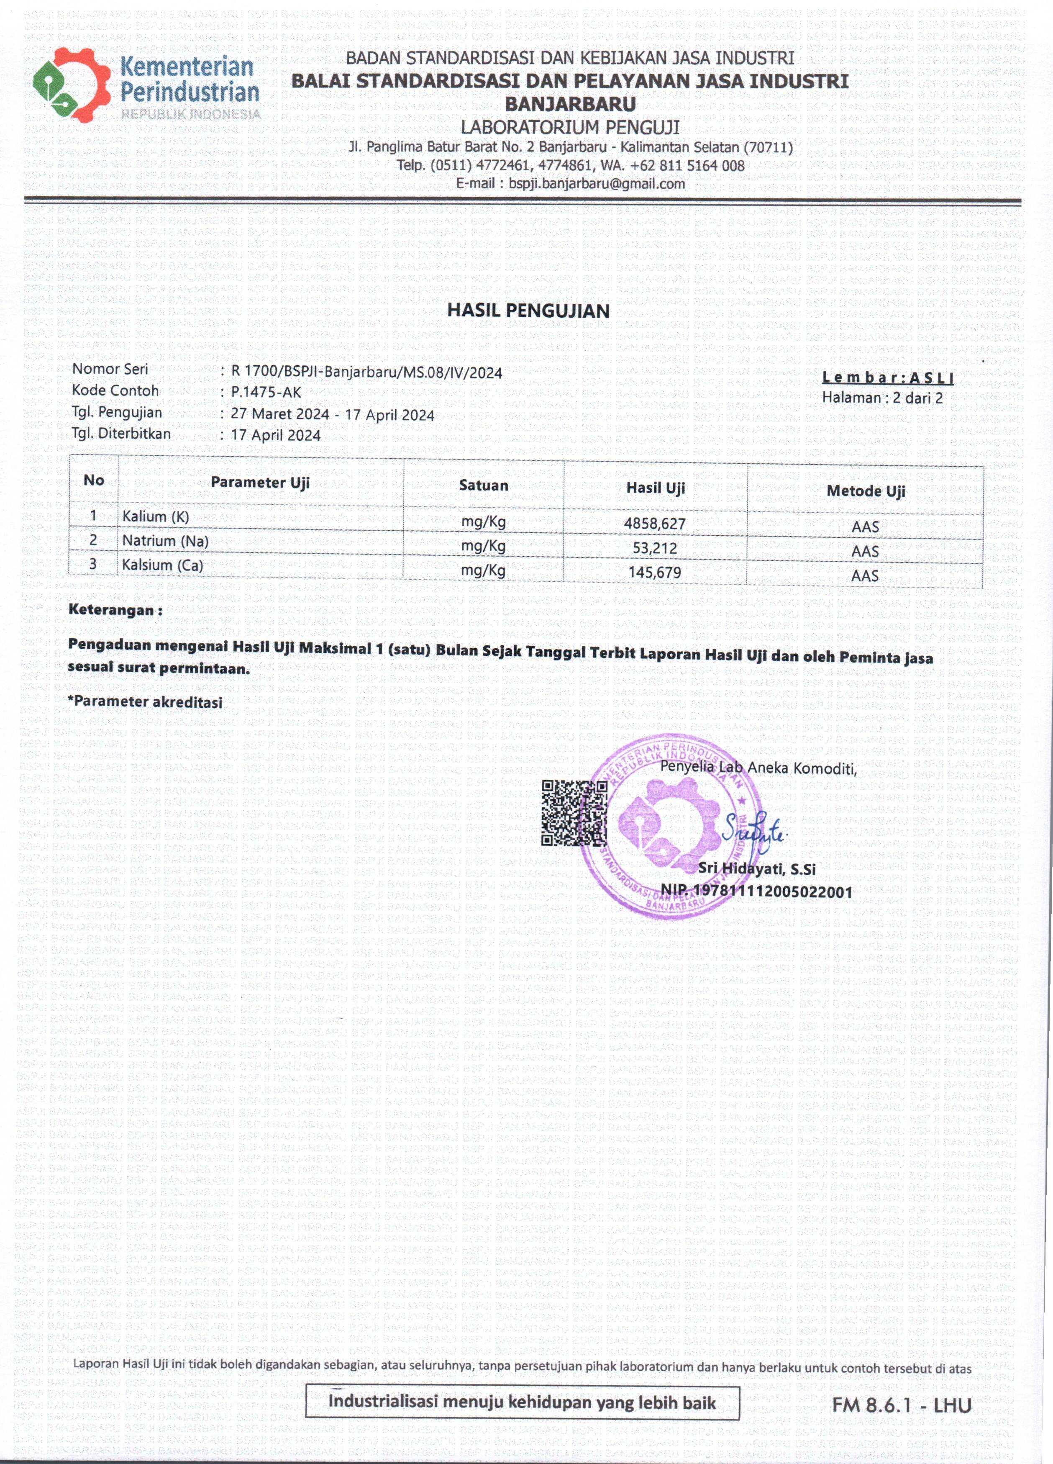

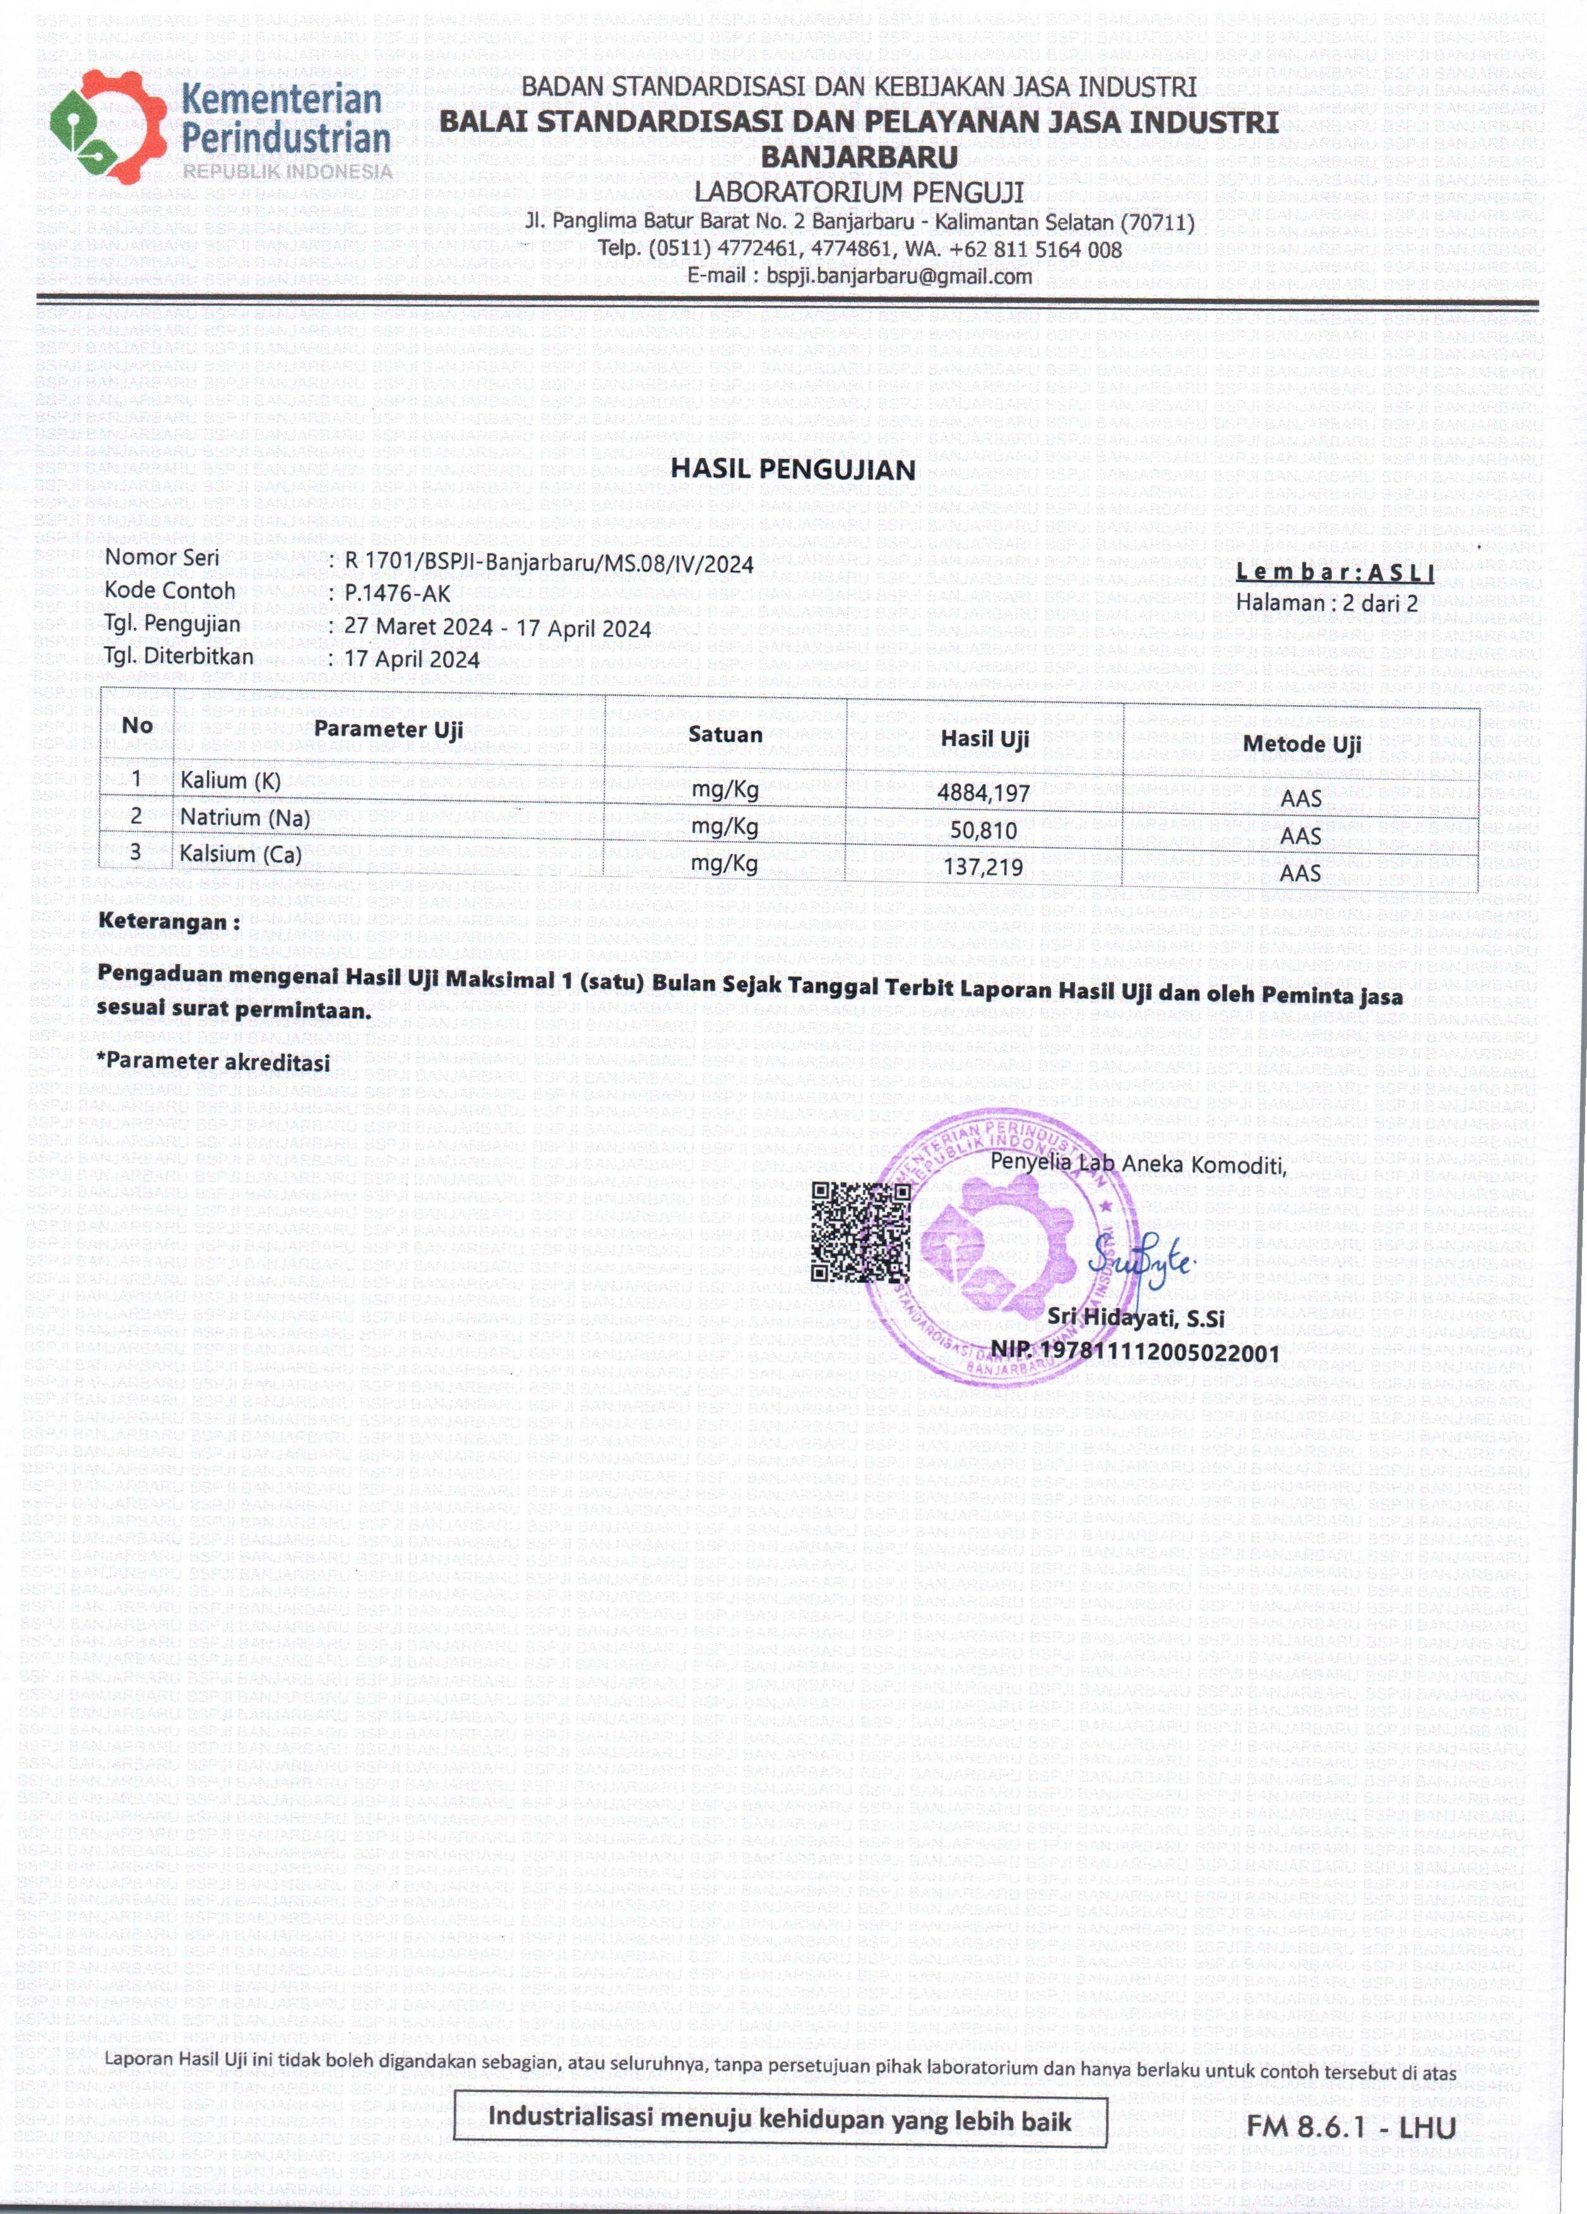

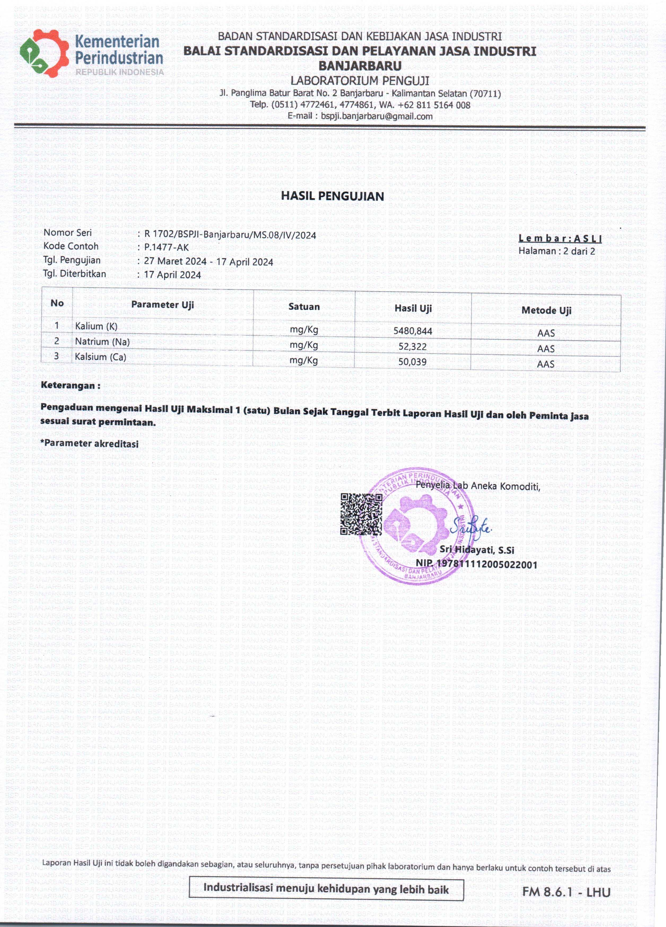

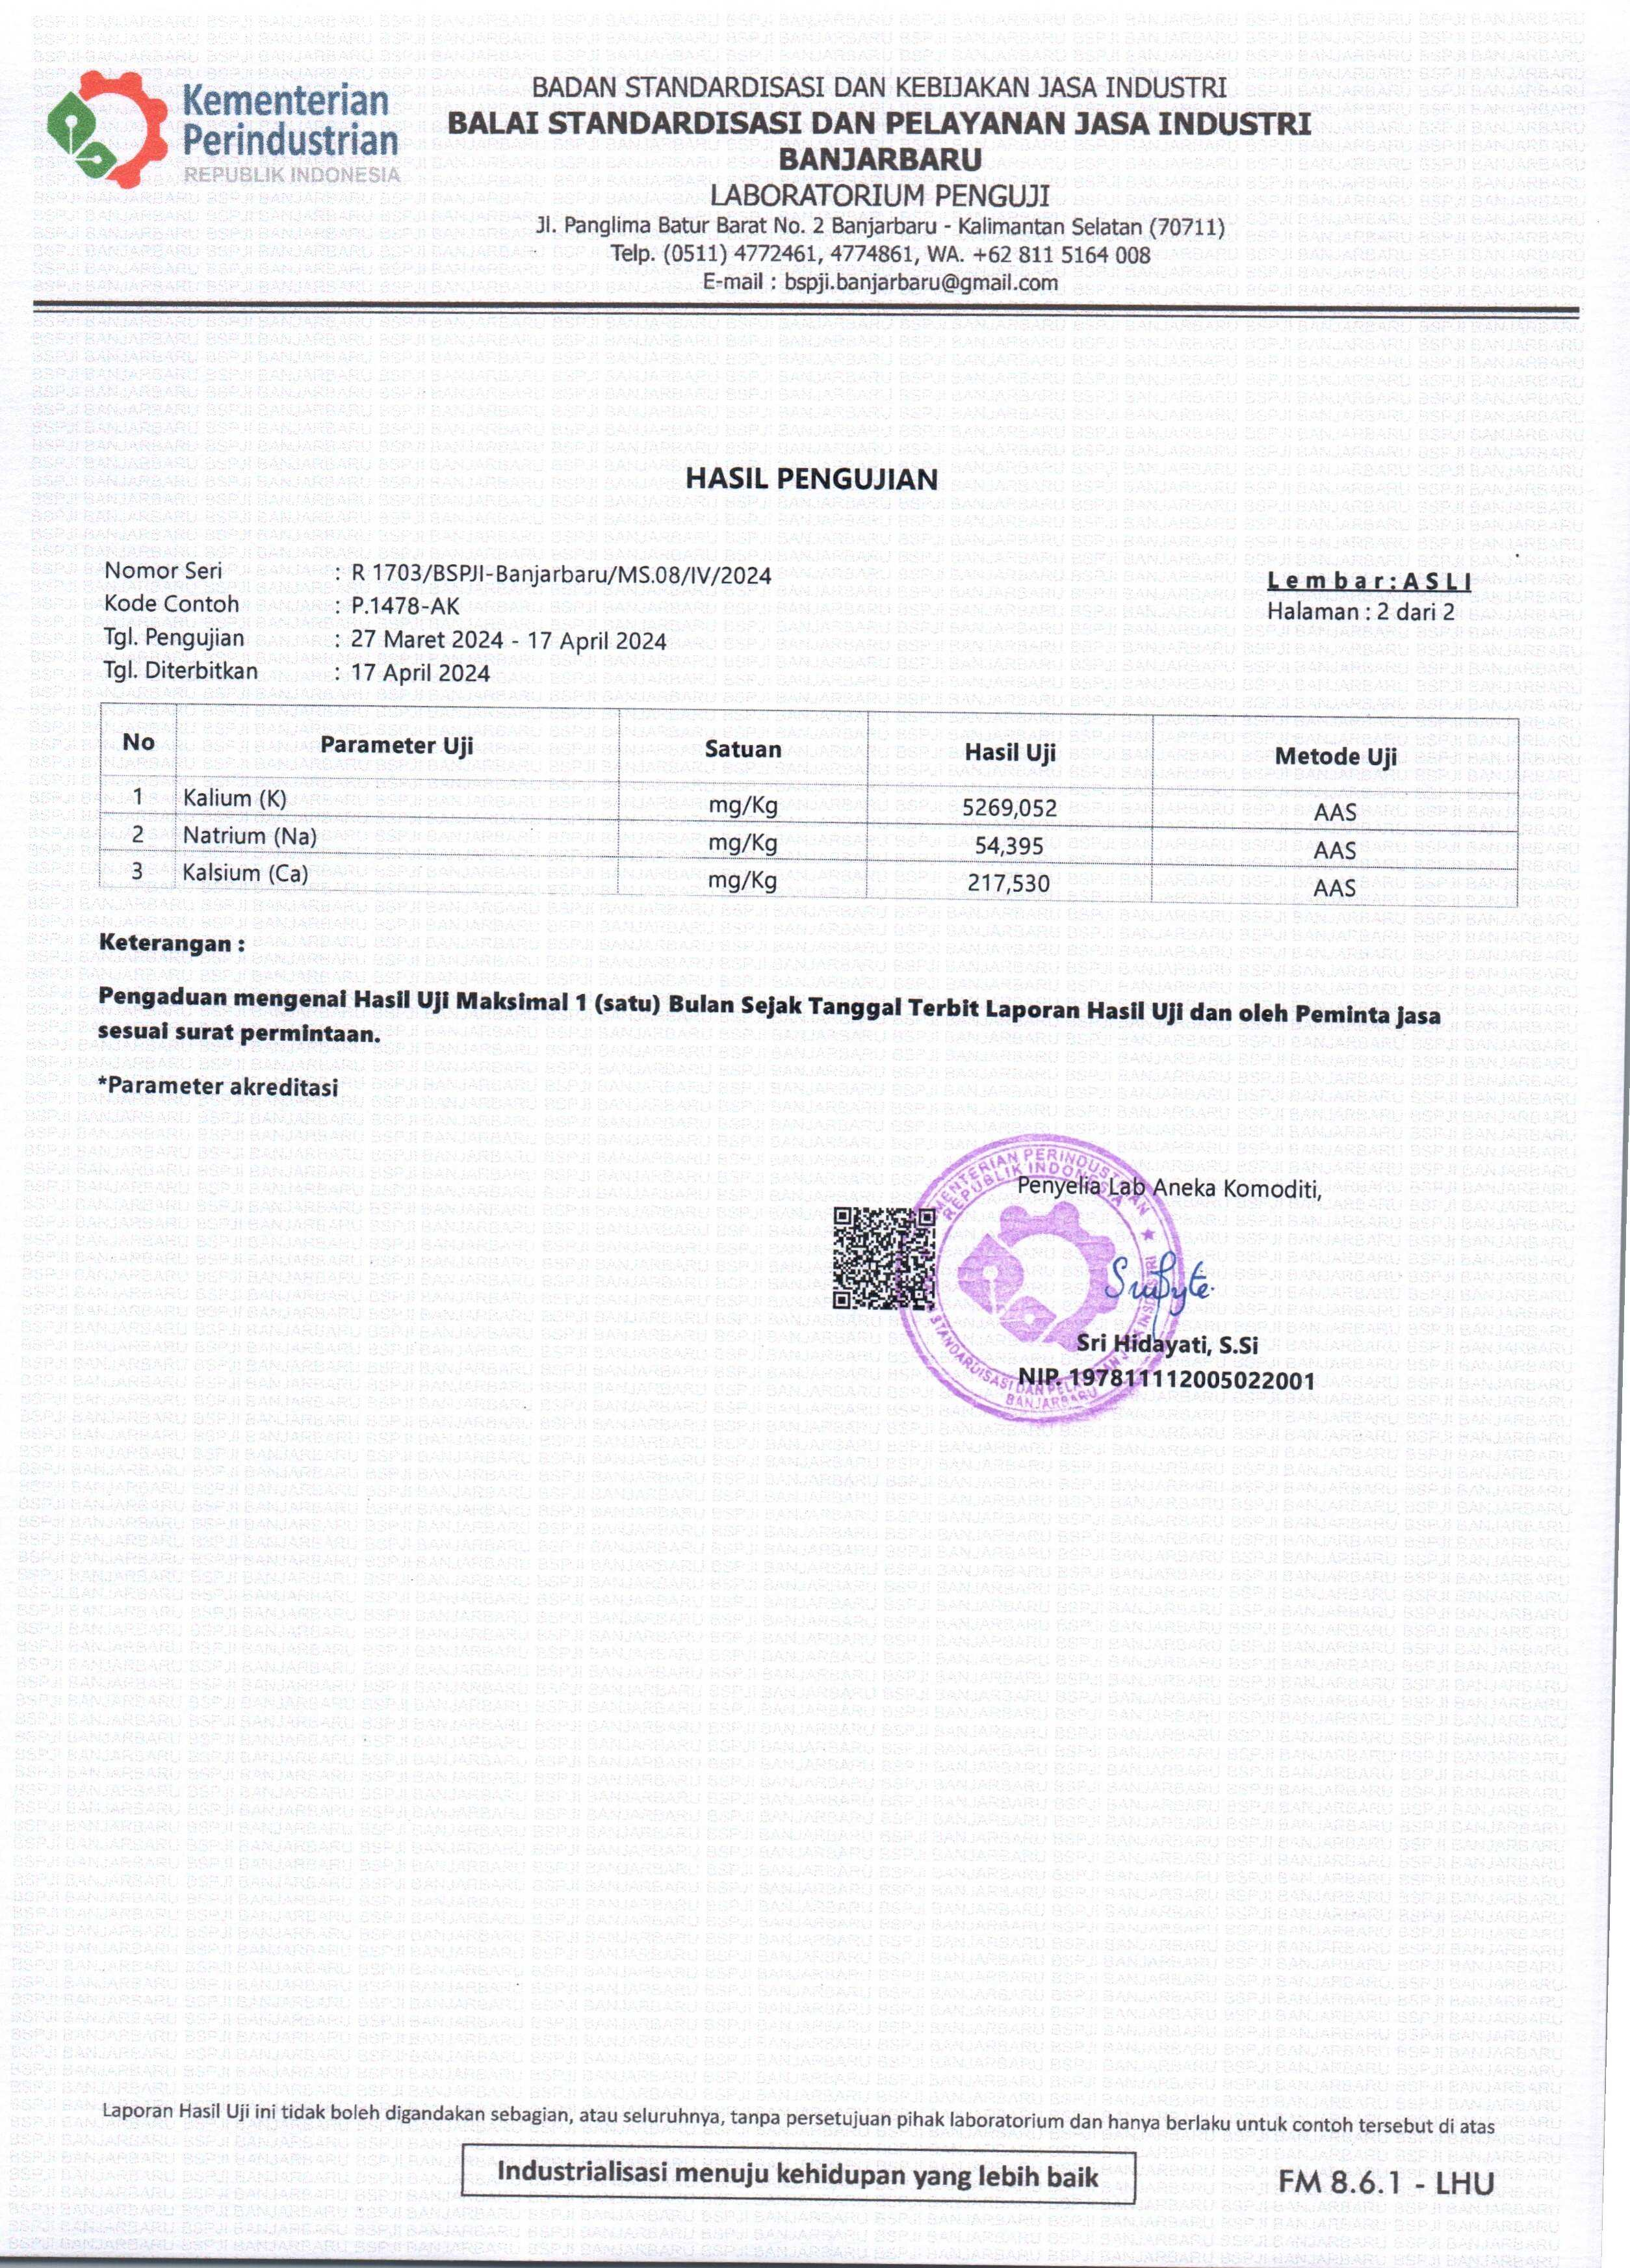

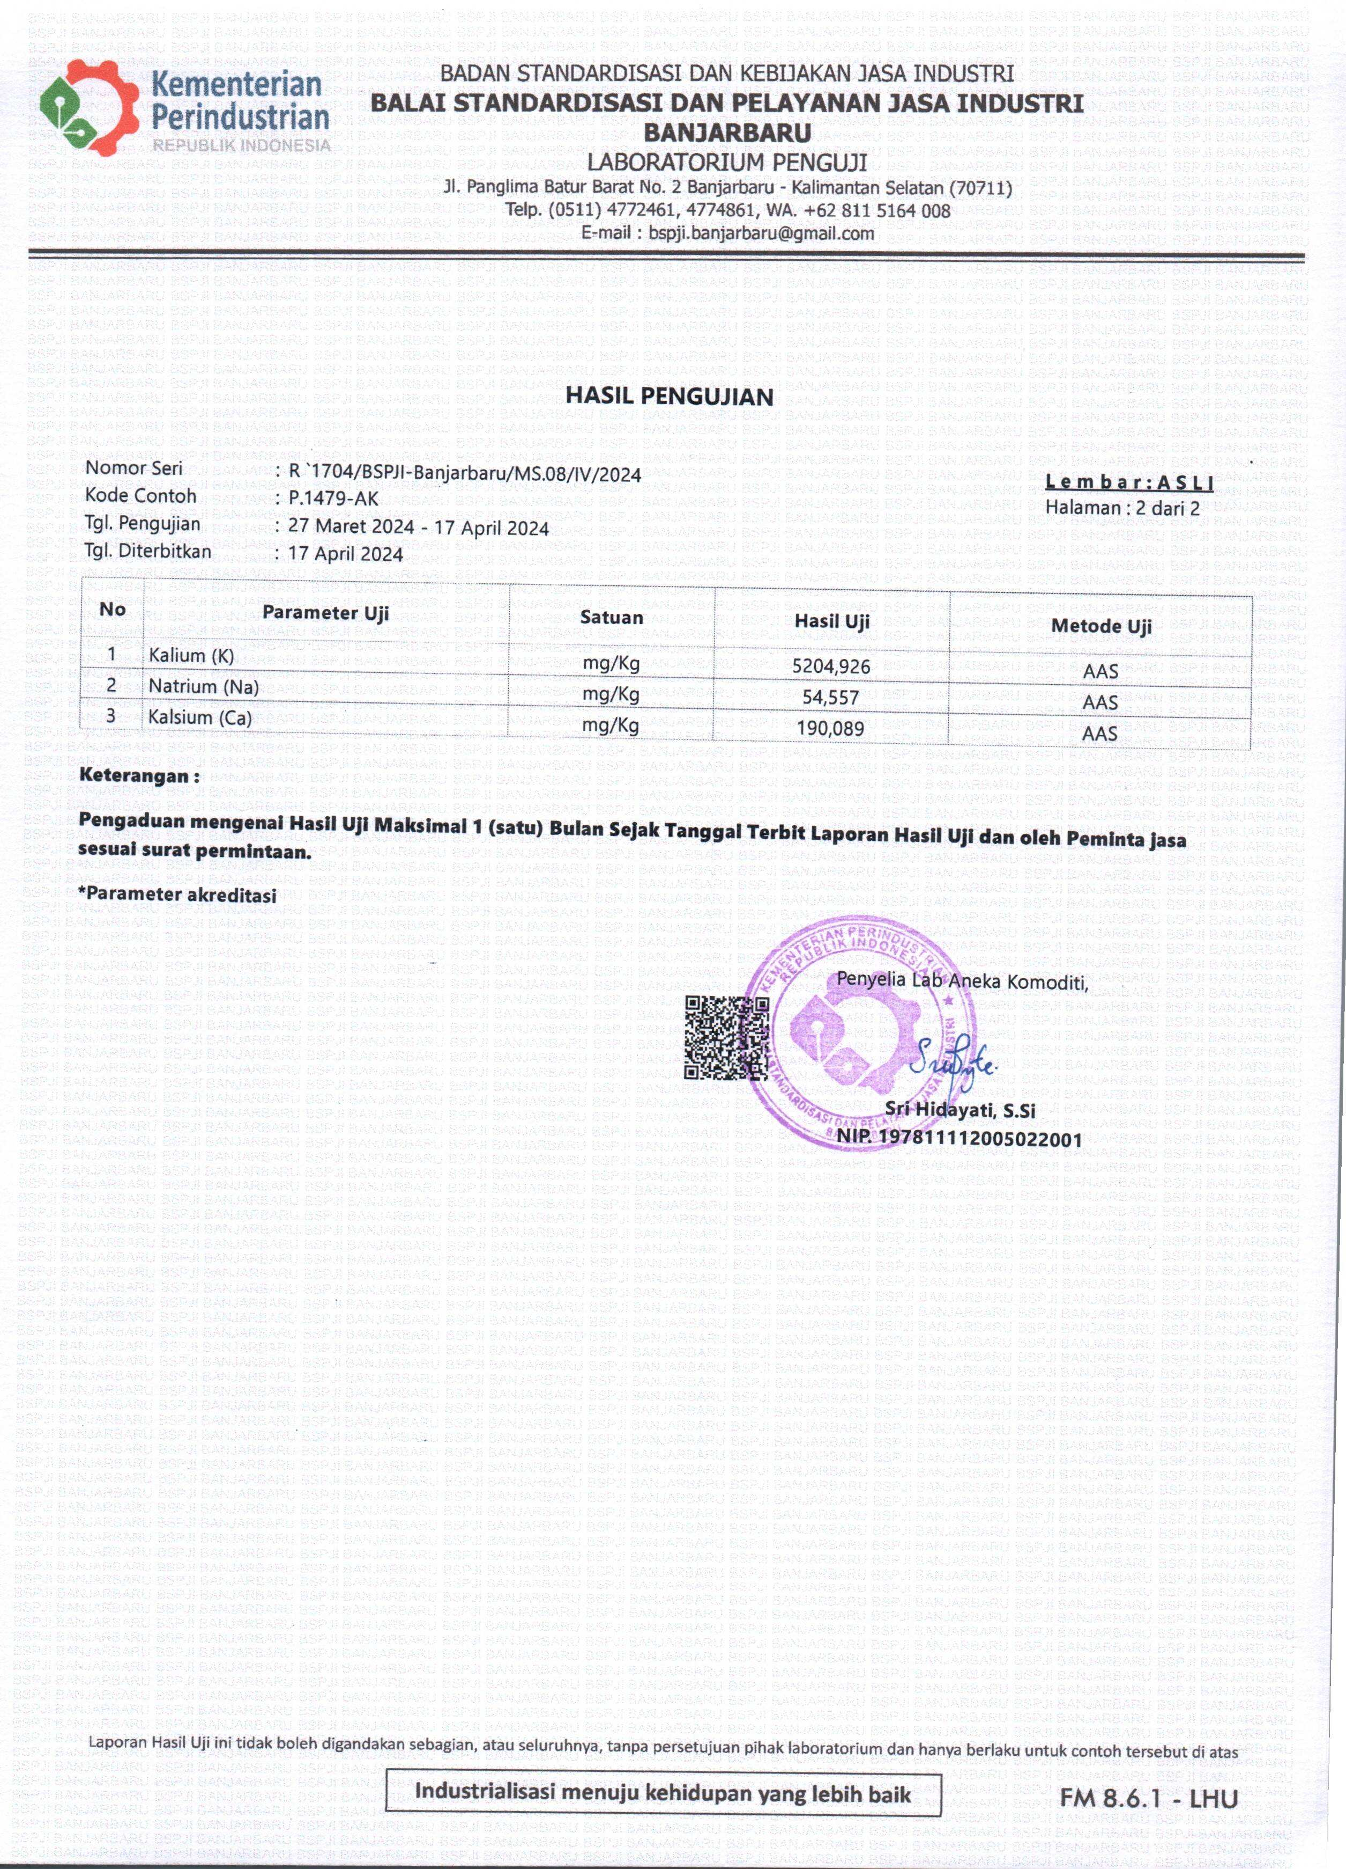

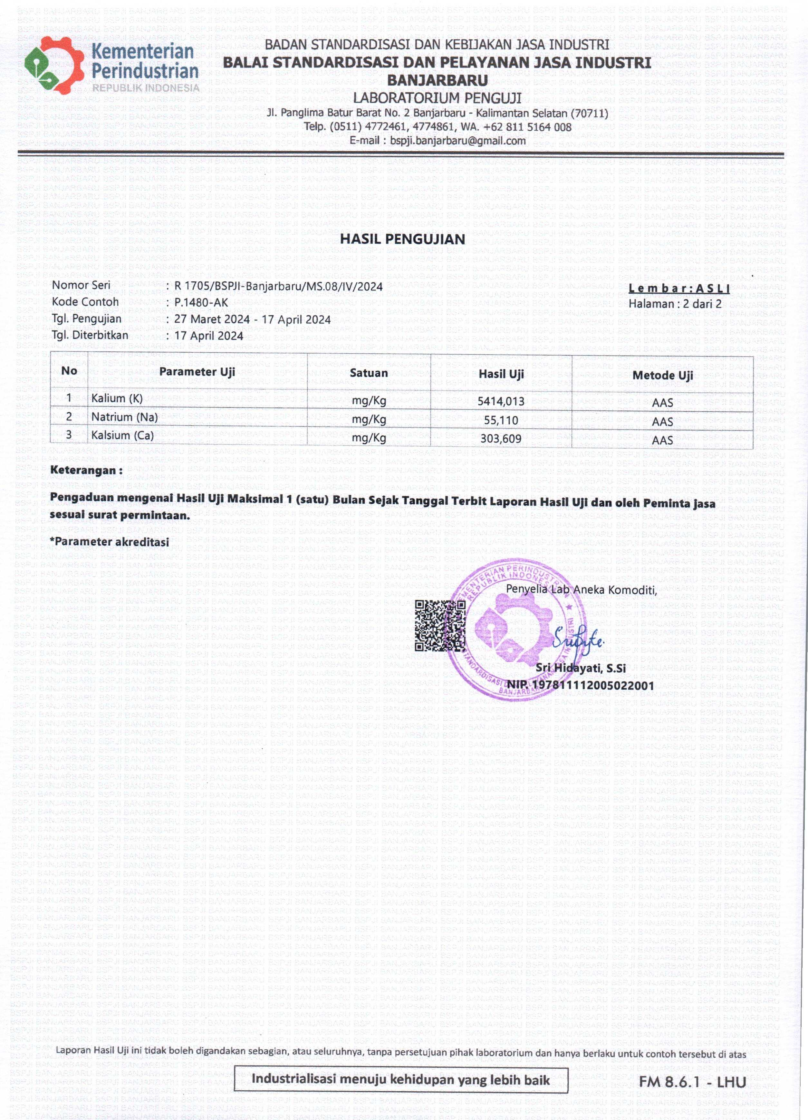

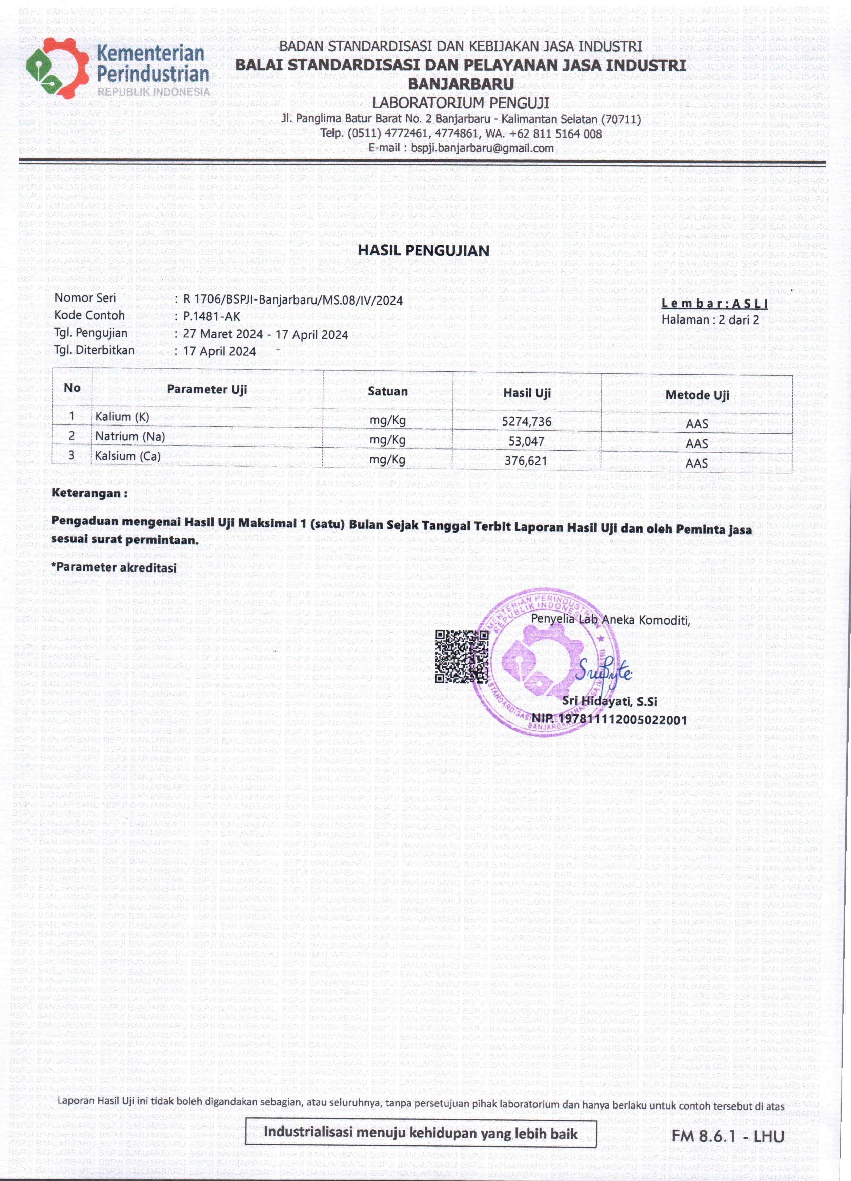

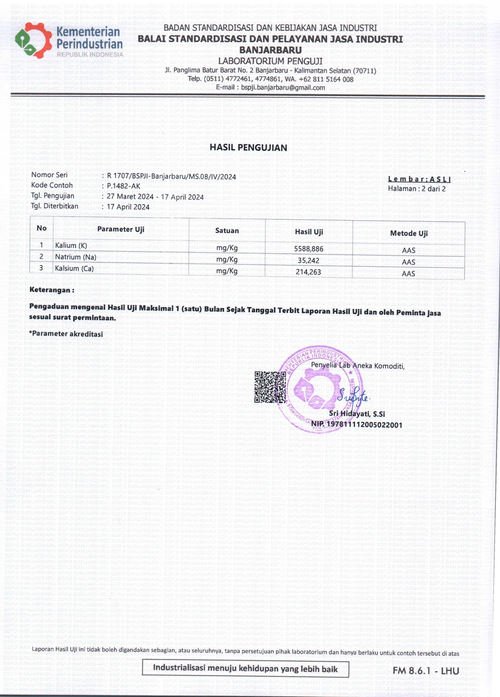

Hasil Analisis Statistik Uji Daya Terima
- Warna
Data Hasil Analisis Statistik Friedman Uji Daya Terima Warna Brownies Kukus

Descriptive Statistics
 | N | Mean | Std. Deviation | Minimum | Maximum | Percentiles
 |  |  |  |  |  | 25th | 50th (Median) | 75th
Mutu Warna | 30 | 3.57 | 1.194 | 1 | 5 | 2.00 | 4.00 | 4.25
Mutu Warna | 30 | 4.03 | .615 | 3 | 5 | 4.00 | 4.00 | 4.00
Mutu Warna | 30 | 3.93 | .740 | 2 | 5 | 3.75 | 4.00 | 4.00
Mutu Warna | 30 | 3.97 | .765 | 2 | 5 | 3.75 | 4.00 | 4.25

Ranks
 | Mean Rank
Mutu Warna | 2.20
Mutu Warna | 2.68
Mutu Warna | 2.55
Mutu Warna | 2.57

Test Statisticsª
N | 30
Chi-Square | 4.462
df | 3
Asymp. Sig. | .216
a. Friedman Test

- Aroma
Data Hasil Analisis Statistik Friedman Uji Daya Terima Aroma Brownies Kukus
Descriptive Statistics
 | N | Mean | Std. Deviation | Minimum | Maximum | Percentiles
 |  |  |  |  |  | 25th | 50th (Median) | 75th
Mutu Aroma | 30 | 3.70 | 1.088 | 1 | 5 | 3.75 | 4.00 | 4.00
Mutu Aroma | 30 | 3.87 | .819 | 2 | 5 | 3.00 | 4.00 | 4.25
Mutu Aroma | 30 | 3.80 | .664 | 3 | 5 | 3.00 | 4.00 | 4.00
Mutu Aroma | 30 | 3.70 | .915 | 2 | 5 | 3.00 | 4.00 | 4.00

Ranks
 | Mean Rank
Mutu Aroma | 2.57
Mutu Aroma | 2.58
Mutu Aroma | 2.47
Mutu Aroma | 2.38

Test Statisticsª
N | 30
Chi-Square | .650
df | 3
Asymp. Sig. | .885
a. Friedman Test

- Tekstur
Data Hasil Analisis Statistik Friedman Uji Daya Terima Tekstur Brownies Kukus
Descriptive Statistics
 | N | Mean | Std. Deviation | Minimum | Maximum | Percentiles
 |  |  |  |  |  | 25th | 50th (Median) | 75th
Mutu Tekstur | 30 | 3.13 | .776 | 2 | 5 | 3.00 | 3.00 | 3.25
Mutu Tekstur | 30 | 3.90 | .759 | 3 | 5 | 3.00 | 4.00 | 4.25
Mutu Tekstur | 30 | 3.50 | .861 | 2 | 5 | 3.00 | 4.00 | 4.00
Mutu Tekstur | 30 | 3.37 | 1.033 | 1 | 5 | 2.75 | 4.00 | 4.00

Ranks
 | Mean Rank
Mutu Tekstur | 2.10
Mutu Tekstur | 3.03
Mutu Tekstur | 2.53
Mutu Tekstur | 2.33

Test Statisticsª
N | 30
Chi-Square | 11.113
df | 3
Asymp. Sig. | .011

- Rasa
Data Hasil Analisis Statistik Friedman Uji Daya Terima Rasa Brownies Kukus
Descriptive Statistics
 | N | Mean | Std. Deviation | Minimum | Maximum | Percentiles
 |  |  |  |  |  | 25th | 50th (Median) | 75th
Mutu Rasa | 30 | 3.60 | .770 | 2 | 5 | 3.00 | 3.50 | 4.00
Mutu Rasa | 30 | 4.07 | .868 | 2 | 5 | 3.00 | 4.00 | 5.00
Mutu Rasa | 30 | 3.93 | .944 | 2 | 5 | 3.00 | 4.00 | 5.00
Mutu Rasa | 30 | 3.30 | .952 | 2 | 5 | 2.75 | 3.00 | 4.00

Ranks
 | Mean Rank
Mutu Rasa | 2.35
Mutu Rasa | 2.95
Mutu Rasa | 2.80
Mutu Rasa | 1.90

Test Statisticsª
N | 30
Chi-Square | 16.200
df | 3
Asymp. Sig. | .001
a. Friedman Test

Hasil Analisis Statistik Uji Mutu Kimia
- Kalium
ANOVA
Kadar kalium
 | Sum of Squares | df | Mean Square | F | Sig.
Between Groups | 2425050220.250 | 3 | 808350073.417 | 603.556 | .000
Within Groups | 10714492.667 | 8 | 1339311.583
Total | 2435764712.917 | 11

- Kalsium
ANOVA
Kadar Kalsium
 | Sum of Squares | df | Mean Square | F | Sig.
Between Groups | 8946640.250 | 3 | 2982213.417 | 8.053 | .008
Within Groups | 2962616.667 | 8 | 370327.083
Total | 11909256.917 | 11

- Natrium
ANOVA
Kadar Natrium
 | Sum of Squares | df | Mean Square | F | Sig.
Between Groups | 5627.583 | 3 | 1875.861 | .605 | .630
Within Groups | 24790.667 | 8 | 3098.833
Total | 30418.250 | 11

