LAMPIRAN
Lampiran 1 Data Penelitian
No | Bank | Capital Adequacy Ratio (CAR) |  |  |  |  | Rata-rata
 |  | 2015 | 2016 | 2017 | 2018 | 2019
1. | PT Bank Mestika Dharma, Tbk | 28,08% | 31,05% | 34,81% | 34,43% | 37,25% | 33,12%
2. | PT Bank Ganesha, Tbk | 13,34% | 14,27% | 35,20% | 29,91% | 31,39% | 24,82%
3. | PT Bank Bumi Arta, Tbk | 16,39% | 25,29% | 25,22% | 24,92% | 25,63% | 23,49%
4. | PT Bank Central Asia, Tbk | 19,39% | 20,04% | 23,10% | 23,65% | 24,49% | 22,13%
5. | PT Bank Mega, Tbk | 16,49% | 23,30% | 24,50% | 21,40% | 24,25% | 21,99%
6. | PT Bank Danamon Indonesia, Tbk | 19,79% | 22,18% | 23.24% | 22,46% | 22,83% | 21,82%
7. | PT Bank Maspion Indonesia | 19,37% | 19,61% | 24,23% | 21,55% | 21,57% | 21,27%
8. | PT Pan Indonesia Bank, Tbk | 16,70% | 19,92% | 21,03% | 22,35% | 23,89% | 20,78%
9. | PT Bank Capital Indonesia, Tbk | 19,69% | 21,85% | 21,01% | 21,48% | 17,62% | 20,33%
10. | PT Bank QNB Indonesia, Tbk | 13,58% | 15,29% | 14,83% | 22,40% | 27,55% | 18,73%
11. | PT Bank Artha Graha Internasional, Tbk | 14,85% | 20,53% | 18,55% | 17,50% | 19,87% | 18,26%
12. | PT Bank CIMB Niaga, Tbk | 16,40% | 17,88% | 18,21% | 18,66% | 19,90% | 18,21%
13. | PT Bank Nusantara Parahyangan,Tbk | 16,83% | 17,87% | 19,91% | 16,81% | 18,82% | 18,05%
14. | PT Bank OCBC NISP, Tbk | 19,19% | 18,00% | 18,23% | 17,01% | 17,74% | 18,03%
15. | PT Bank Sinarmas, Tbk | 17,70% | 14,84% | 16,72% | 18,83% | 17,09% | 17,04%
16. | PT Bank Permata Indonesia, Tbk | 13,96% | 15,10% | 16,99% | 17,73% | 19,90% | 16,74%
17. | PT Bank Mayapada International, Tbk | 12,34% | 13,26% | 13,70% | 12,89% | 14,59% | 13,36%
18. | PT Bank Bukopin, Tbk | 14,65% | 15,95% | 17,02% | 13,48% | 11,09% | 14,44%

No | Nama Bank | Non Performing Loan (NPL) |  |  |  |  | Rata-rata
 |  | 2015 | 2016 | 2017 | 2018 | 2019
1. | PT Bank Maspion Indonesia, Tbk | 0,76% | 0,48% | 0,98% | 1,43% | 2,36% | 1,20%
2. | PT Bank Central Asia, Tbk | 0,66% | 1,08% | 1,47% | 1,54% | 1,47% | 1,24%
3. | PT Bank Bumi Arta, Tbk | 0,53% | 0,80% | 1,76% | 1,71% | 1,60% | 1,28%
4. | PT Bank OCBC NISP, Tbk | 1,39% | 1,41% | 1,89% | 1,72% | 1,85% | 1,65%
5. | PT Bank Capital Indonesia, Tbk | 0,26% | 0,89% | 3,26% | 3,18% | 2,88% | 2,09%
6. | PT Pan Indonesia Bank, Tbk | 1,66% | 2,64% | 2,94% | 2,65% | 3,03% | 2,58%
7. | PT Bank Mega, Tbk | 2,53% | 3,37% | 3,57% | 2,34% | 1,75% | 2,71%
8. | PT Bank Ganesha | 4,63% | 2,68% | 1,33% | 0,80% | 4,22% | 2,73%
9. | PT Bank Mayapada International, Tbk | 2,89% | 1,04% | 1,68% | 3,69% | 4,99% | 2,86%
10. | PT Bank Mestika Dharma | 2,50% | 3,71% | 2,57% | 3,14% | 2,41% | 2,87%
11. | PT Bank Danamon Indonesia, Tbk | 2,69% | 3,59% | 3,55% | 3,47% | 2,96% | 3,25%
12. | PT Bank Sinarmas, Tbk | 2,55% | 2,97% | 3,23% | 3,75% | 4,03% | 3,31%
13. | PT Bank CIMB Niaga, Tbk | 4,18% | 3,98% | 3,95% | 3,54% | 3,05% | 3,74%
14. | PT Bank QNB Indonesia, Tbk | 0,28% | 3,85% | 8,76% | 2,63% | 3,70% | 3,84%
15. | PT Bank Permata Indonesia, Tbk | 1,62% | 3,48% | 6,41% | 4,59% | 3,78% | 3,98%
16. | PT Bank Bukopin, Tbk | 2,71% | 3,30% | 4,07% | 4,24% | 6,40% | 4,14%
17. | PT Bank Artha Graha Internasional, Tbk | 4,33% | 2,41% | 3,57% | 4,24% | 7,21% | 4,35%
18. | PT Bank Nusantara Parahyangan,Tbk | 2,98% | 4,97% | 5,99% | 6,59% | 5,19% | 5,14%

No | Bank | Beban Operasi Pendapatan Operasi |  |  |  |  | Rata-rata
 |  | 2015 | 2016 | 2017 | 2018 | 2019
1. | PT Bank Central Asia, Tbk | 67,44% | 69,75% | 65,20% | 63,29% | 65,20% | 66,18%
2. | PT Bank Mestika Dharma, Tbk | 67,31% | 76,99% | 72,97% | 73,62% | 65,35% | 71,25%
3. | PT Bank Danamon Indonesia, Tbk | 85,31% | 78,93% | 69,80% | 69,30% | 73,34% | 75,34%
4. | PT Bank OCBC NISP, Tbk | 97,04% | 78,73% | 75,38% | 73,19% | 73,52% | 79,57%
5. | PT Bank Mega, Tbk | 83,77% | 82,01% | 80,92% | 80,21% | 72,23% | 79,83%
6. | PT Pan Indonesia Bank, Tbk | 83,22% | 82,77% | 79,41% | 80,24% | 77,83% | 80,69%
7. | PT Bank Mayapada International, Tbk | 89,13% | 78,38% | 78,80% | 87,59% | 93,55% | 85,49%
8. | PT Bank Ganesha, Tbk | 99,60% | 89,20% | 78,37% | 80,03% | 84,69% | 86,38%
9. | PT Bank Bumi Arta, Tbk | 89,36% | 87,91% | 85,95% | 82,30% | 89,57% | 87,02%
10. | PT Bank Maspion Indonesia | 95,84% | 85,80% | 83,02% | 84,96% | 86,69% | 87,26%
11. | PT Bank Sinarmas, Tbk | 94,30% | 85,79% | 88,20% | 84,01% | 85,11% | 87,48%
12. | PT Bank CIMB Niaga, Tbk | 98,01% | 94,03% | 85,42% | 82,22% | 82,02% | 88,34%
13. | PT Bank Bukopin, Tbk | 87,68% | 87,60% | 86,73% | 92,82% | 95,95% | 90,16%
14. | PT Bank Capital Indonesia, Tbk | 87,90% | 88,39% | 83,38% | 93,36% | 99,01% | 90,41%
15. | PT Bank Permata Indonesia, Tbk | 85,10% | 110,94% | 87,29% | 94,72% | 87,98% | 93,21%
16. | PT Bank Artha Graha Internasional, Tbk | 90,75% | 93,30% | 93,83% | 95,12% | 97,63% | 94,13%
17. | PT Bank Nusantara Parahyangan,Tbk | 99,38% | 98,47% | 101,38% | 96,40% | 99,36% | 99,00%
18. | PT Bank QNB Indonesia, Tbk | 99,60% | 103,42% | 89,75% | 112,28% | 113,59% | 103,73%

No | Bank | Loan to Deposit Ratio (LDR) |  |  |  |  | Rata-rata
 |  | 2015 | 2016 | 2017 | 2018 | 2019
1. | PT Bank Capital Indonesia, Tbk | 58,31% | 62,19% | 56,08% | 54,07% | 53,96% | 56,92%
2. | PT Bank Mega, Tbk | 66,56% | 64,88% | 56,06% | 59,83% | 71,31% | 63,73%
3. | PT Bank Central Asia, Tbk | 74,91% | 78,92% | 75,05% | 77,85% | 81,03% | 77,55%
4. | PT Bank Bukopin, Tbk | 80,32% | 81,79% | 75,85% | 72,82% | 78,82% | 77,92%
5. | PT Bank Ganesha, Tbk | 65,94% | 66,48% | 96,67% | 76,93% | 86,91% | 78,59%
6. | PT Bank Bumi Arta, Tbk | 79,86% | 82,63% | 76,72% | 82,81% | 78,02% | 80,01%
7. | PT Bank Sinarmas, Tbk | 80,56% | 74,53% | 78,50% | 85,80% | 82,79% | 80,44%
8. | PT Bank Artha Graha Internasional, Tbk | 83,10% | 80,93% | 86,80% | 82,66% | 74,66% | 81,63%
9. | PT Bank Mayapada International, Tbk | 83,36% | 80,38% | 85,07% | 84,74% | 89,20% | 84,55%
10. | PT Bank Permata Indonesia, Tbk | 88,79% | 89,71% | 74,58% | 88,99% | 86,91% | 85,80%
11. | PT Bank OCBC NISP, Tbk | 84,61% | 94,70% | 85,89% | 91,13% | 73,52% | 85,97%
12. | PT Bank QNB Indonesia, Tbk | 96,33% | 90,02% | 94,52% | 72,08% | 80,00% | 86,59%
13. | PT Bank Nusantara Parahyangan,Tbk | 86,49% | 84,79% | 84,35% | 91,24% | 91,33% | 87,64%
14. | PT Bank Mestika Dharma, Tbk | 101,09% | 95,86% | 84,97% | 83,77% | 86,22% | 90,38%
15. | PT Bank Maspion Indonesia | 80,51% | 88,71% | 101,08% | 95,00% | 97,54% | 92,57%
16. | PT Bank Danamon Indonesia, Tbk | 92,74% | 90,16% | 92,80% | 93,52% | 94,30% | 92,70%
17. | PT Pan Indonesia Bank, Tbk | 92,24% | 93,71% | 86,58% | 90,25% | 104,10% | 93,38%
18. | PT Bank CIMB Niaga, Tbk | 92,35% | 94,49% | 95,65% | 90,66% | 95,89% | 93,81%

No | Bank | Net Interest Margin (NIM) |  |  |  |  | Rata-rata
 |  | 2015 | 2016 | 2017 | 2018 | 2019
1. | PT Bank Mestika Dharma | 7,94% | 7,56% | 7,67% | 7,04% | 6,68% | 7,38%
2. | PT Bank Sinarmas, Tbk | 6,30% | 5,70% | 6,41% | 7,45% | 8,20% | 6,81%
3. | PT Bank Danamon Indonesia, Tbk | 7,33% | 7,19% | 7,47% | 6,48% | 5,47% | 6,79%
4. | PT Bank Central Asia, Tbk | 6,53% | 7,04% | 6,32% | 6,06% | 6,19% | 6,43%
5. | PT Bank Mega, Tbk | 5,47% | 6,65% | 6,47% | 5,01% | 5,26% | 5,77%
6. | PT Bank Nusantara Parahyangan,Tbk | 4,62% | 5,16% | 6,34% | 6,13% | 6,20% | 5,69%
7. | PT Bank CIMB Niaga, Tbk | 5,22% | 5,23% | 5,55% | 4,81% | 5,12% | 5,19%
8. | PT Bank Ganesha | 4,53% | 5,09% | 5,77% | 5,34% | 4,67% | 5,08%
9. | PT Bank Artha Graha Internasional, Tbk | 4,71% | 5,00% | 4,89% | 4,31% | 4,63% | 4,71%
10. | PT Bank Bumi Arta, Tbk | 5,18% | 4,67% | 4,80% | 4,57% | 3,84% | 4,61%
11. | PT Bank Maspion Indonesia | 3,85% | 4,95% | 5,48% | 4,56% | 4,20% | 4,61%
12. | PT Pan Indonesia Bank, Tbk | 4,03% | 4,98% | 4,47% | 4,35% | 4,44% | 4,45%
13. | PT Bank OCBC NISP, Tbk | 3,82% | 5,23% | 4,31% | 4,24% | 3,89% | 4,30%
14. | PT Bank Mayapada International, Tbk | 3,93% | 4,65% | 4,44% | 3,95% | 3,27% | 4,05%
15. | PT Bank Capital Indonesia, Tbk | 4,44% | 4,06% | 4,45% | 3,91% | 3,35% | 4,04%
16. | PT Bank Permata Indonesia, Tbk | 3,58% | 3,94% | 3,45% | 3,91% | 4,02% | 3,78%
17. | PT Bank Bukopin, Tbk | 3,26% | 3,22% | 3,05% | 3,13% | 2,79% | 3,09%
18. | PT Bank QNB Indonesia, Tbk | 2,33% | 2,43% | 2,77% | 1,84% | 2,17% | 2,31%

Lampiran 2 Tabel Distribusi T
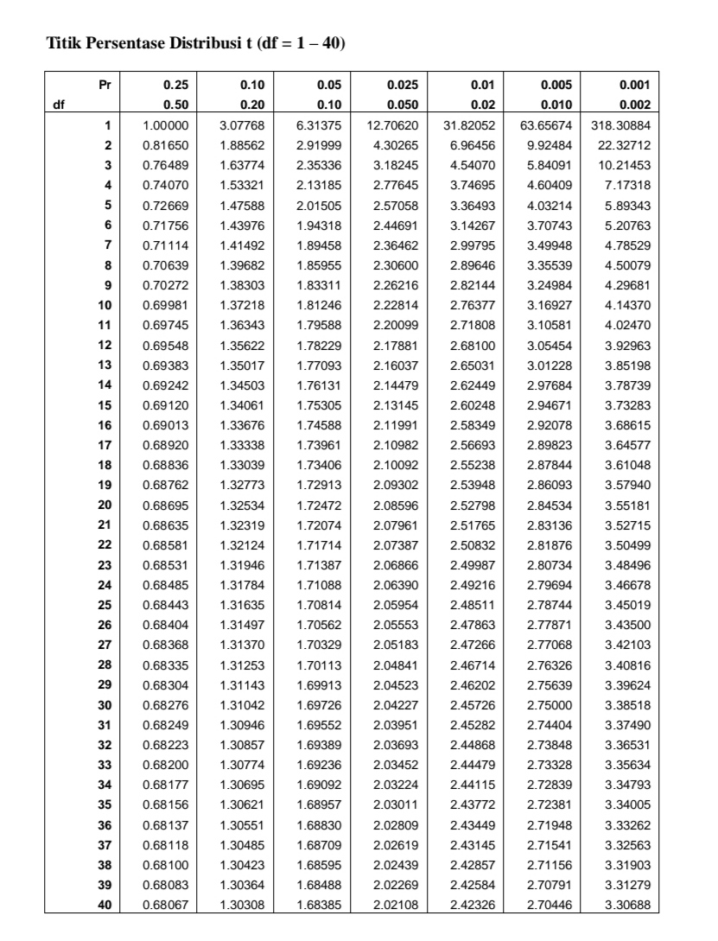
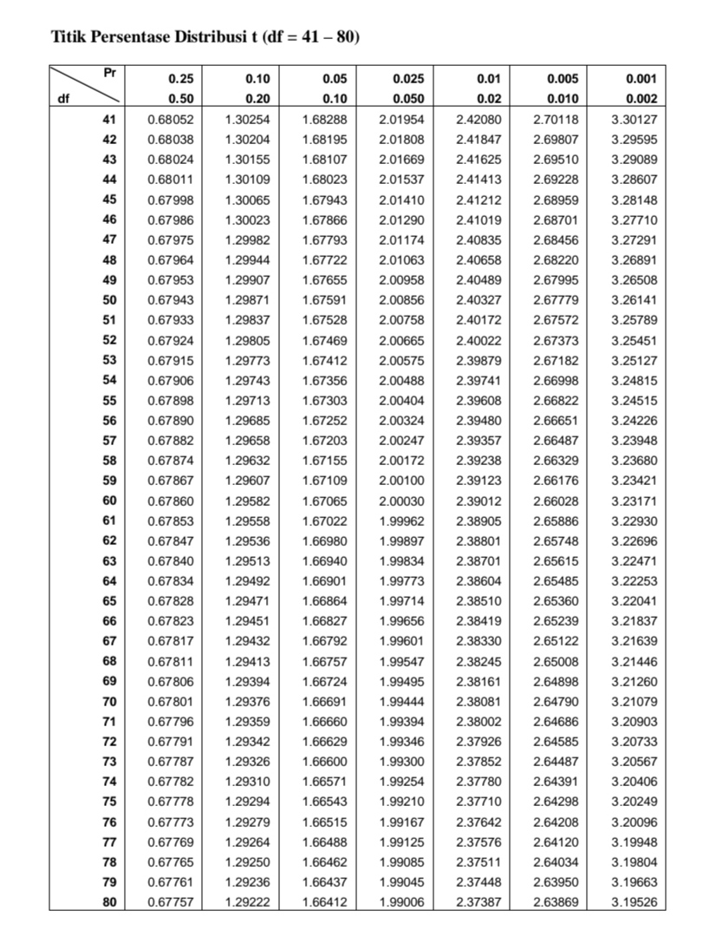

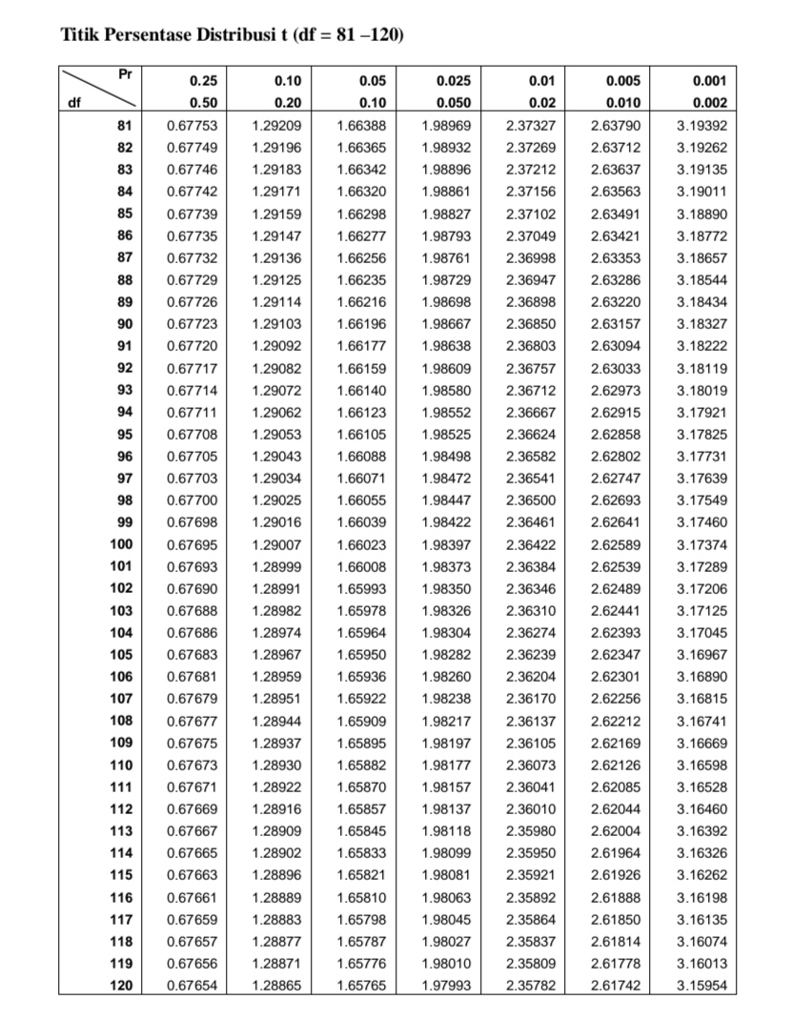
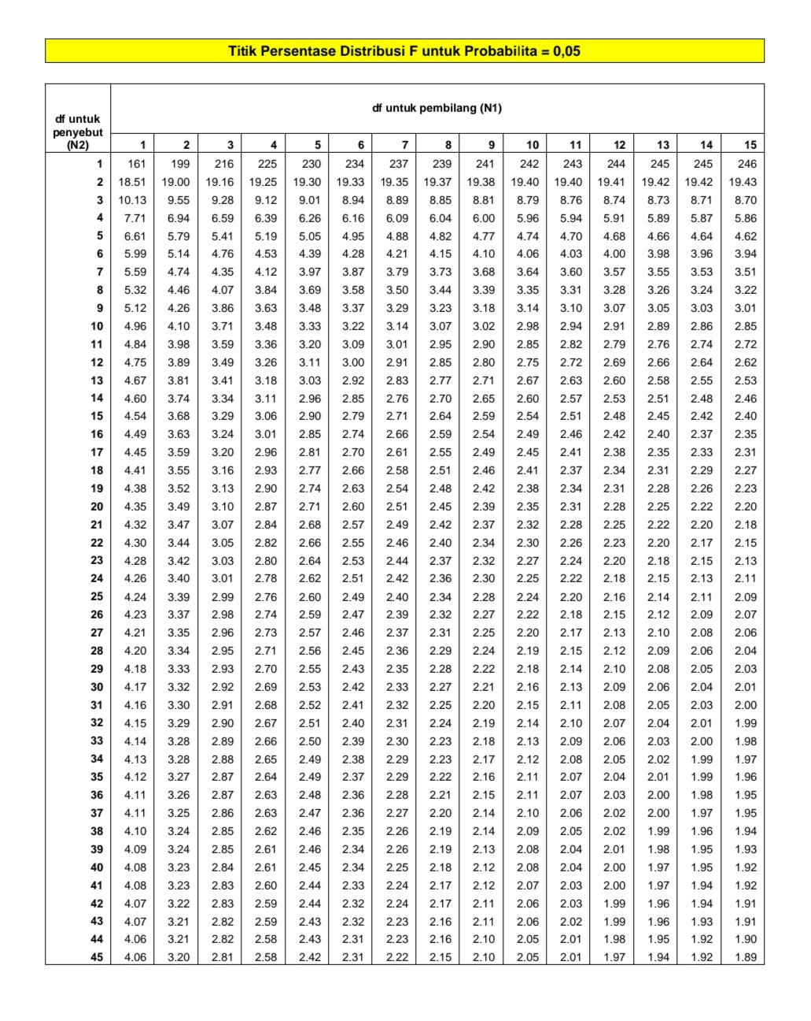
Lampiran 3 Distribusi F
Lampiran 4 Hasil Uji Statistik
Descriptive Statistiks
 | N | Minimum | Maximum | Mean | Std. Deviation
NIM | 90 | 1.84 | 8.20 | 4.9490 | 1.40113
CAR | 90 | 11.09 | 37.25 | 20.1600 | 5.36356
NPL | 90 | .19 | 4.66 | 1.7990 | 1.18362
BOPO | 90 | 63.29 | 113.59 | 85.8581 | 10.68340
LDR | 90 | 53.96 | 104.10 | 82.7870 | 11.16429
Valid N (listwise) | 90

One-Sample Kolmogorov-Smirnov Test
 |  | Unstandardized Residual
N |  | 90
Normal Parameters^{a,b} | Mean | .0000000
 | Std. Deviation | 1.06245885
Most Extreme Differences | Absolute | .073
 | Positive | .073
 | Negatif | -.045
Test Statistik |  | .073
Asymp. Sig. (2-tailed) |  | .200^{c,d}
a. Test distribution is Normal.
b. Calculated from data.
c. Lilliefors Significance Correction.
d. This is a lower bound of the true significance.

Coefficientsª
Model |  | Unstandardized Coefficients |  | Standardized Coefficients | t | Sig. | Collinearity Statistiks
 |  | B | Std. Error | Beta |  |  | Tolerance | VIF
1 | (Constant) | 8.437 | 1.601 |  | 5.271 | .000
 | CAR | .072 | .024 | .277 | 3.010 | .003 | .800 | 1.250
 | NPL | .327 | .112 | .276 | 2.923 | .004 | .757 | 1.320
 | BOPO | -.074 | .013 | -.566 | -5.707 | .000 | .689 | 1.452
 | LDR | .010 | .010 | .080 | .971 | .334 | .987 | 1.013
a. Dependent Variabel: NIM

Model Summary^{b}
Model | R | R Square | Adjusted R Square | Std. Error of the Estimate | Durbin-Watson
1 | .652ª | .425 | .398 | 1.08717 | 1.893
a. Predictors: (Constant), LDR, CAR, NPL, BOPO
b. Dependent Variabel: NIM

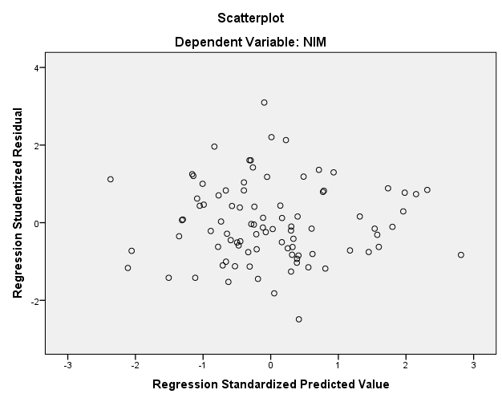

Correlations
 |  | CAR | NIM
CAR | Pearson Correlation | 1 | .437**
 | Sig. (2-tailed) |  | .000
 | N | 90 | 90
NIM | Pearson Correlation | .437** | 1
 | Sig. (2-tailed) | .000
 | N | 90 | 90
**. Correlation is significant at the 0.01 level (2-tailed).

Model Summary
Model | R | R Square | Adjusted R Square | Std. Error of the Estimate
1 | .437ª | .191 | .181 | 1.26772
a. Predictors: (Constant), CAR

Coefficientsª
Model |  | Unstandardized Coefficients |  | Standardized Coefficients | T | Sig.
 |  | B | Std. Error | Beta
1 | (Constant) | 2.650 | .522 |  | 5.072 | .000
 | CAR | .114 | .025 | .437 | 4.552 | .000
a. Dependent Variabel: NIM

Correlations
 |  | NPL | NIM
NPL | Pearson Correlation | 1 | -.087
 | Sig. (2-tailed) |  | .415
 | N | 90 | 90
NIM | Pearson Correlation | -.087 | 1
 | Sig. (2-tailed) | .415
 | N | 90 | 90

Model Summary
Model | R | R Square | Adjusted R Square | Std. Error of the Estimate
1 | .087ª | .008 | -.004 | 1.40373
a. Predictors: (Constant), NPL

Coefficientsª
Model |  | Unstandardized Coefficients |  | Standardized Coefficients | t | Sig.
 |  | B | Std. Error | Beta
1 | (Constant) | 5.134 | .270 |  | 18.997 | .000
 | NPL | -.103 | .126 | -.087 | -.819 | .415
a. Dependent Variabel: NIM

Correlations
 |  | BOPO | NIM
BOPO | Pearson Correlation | 1 | -.561**
 | Sig. (2-tailed) |  | .000
 | N | 90 | 90
NIM | Pearson Correlation | -.561** | 1
 | Sig. (2-tailed) | .000
 | N | 90 | 90
**. Correlation is significant at the 0.01 level (2-tailed).

Model Summary
Model | R | R Square | Adjusted R Square | Std. Error of the Estimate
1 | .561ª | .314 | .307 | 1.16681
a. Predictors: (Constant), BOPO

Coefficientsª
Model |  | Unstandardized Coefficients |  | Standardized Coefficients | T | Sig.
 |  | B | Std. Error | Beta
1 | (Constant) | 11.262 | 1.002 |  | 11.244 | .000
 | BOPO | -.074 | .012 | -.561 | -6.351 | .000
a. Dependent Variabel: NIM

Correlations
 |  | LDR | NIM
LDR | Pearson Correlation | 1 | .138
 | Sig. (2-tailed) |  | .196
 | N | 90 | 90
NIM | Pearson Correlation | .138 | 1
 | Sig. (2-tailed) | .196
 | N | 90 | 90

Model Summary
Model | R | R Square | Adjusted R Square | Std. Error of the Estimate
1 | .138ª | .019 | .008 | 1.39566
a. Predictors: (Constant), LDR

Coefficientsª
Model |  | Unstandardized Coefficients |  | Standardized Coefficients | T | Sig.
 |  | B | Std. Error | Beta
1 | (Constant) | 3.519 | 1.107 |  | 3.180 | .002
 | LDR | .017 | .013 | .138 | 1.303 | .196
a. Dependent Variabel: NIM

Model Summary
Model | R | R Square | Adjusted R Square | Std. Error of the Estimate
1 | .652ª | .425 | .398 | 1.08717
a. Predictors: (Constant), LDR, CAR, NPL, BOPO

Coefficientsª
Model |  | Unstandardized Coefficients |  | Standardized Coefficients | T | Sig.
 |  | B | Std. Error | Beta
1 | (Constant) | 8.437 | 1.601 |  | 5.271 | .000
 | CAR | .072 | .024 | .277 | 3.010 | .003
 | NPL | .327 | .112 | .276 | 2.923 | .004
 | BOPO | -.074 | .013 | -.566 | -5.707 | .000
 | LDR | .010 | .010 | .080 | .971 | .334
a. Dependent Variabel: NIM

ANOVAª
Model |  | Sum of Squares | df | Mean Square | F | Sig.
1 | Regression | 74.257 | 4 | 18.564 | 15.706 | .000^{b}
 | Residual | 100.465 | 85 | 1.182
 | Total | 174.721 | 89
a. Dependent Variabel: NIM
b. Predictors: (Constant), LDR, CAR, NPL, BOPO

